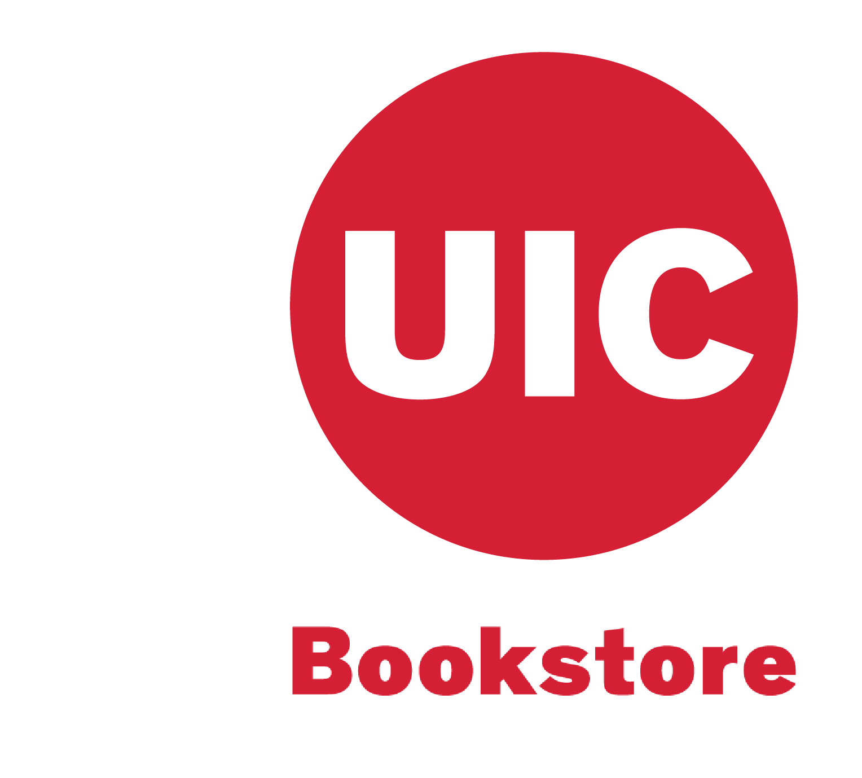

**DIRECT ACCESS PROGRAM**

# **Marketing Research Study**

Talish Barmare

# 

# 

# 

# 

# **Executive Summary**

Our client, the UIC Bookstore is owned and operated by the University of Illinois at Chicago. In order to address the problem of the declining retail bookstore industry, the UIC bookstore introduced the Direct Access Program for the students. The Program grants students’ immediate access to discounted course materials in digital format. Worth noting, the pricing for the e-books is significantly reduced compared to the purchase of a printed textbooks. If the program is available for a class, students have access via Blackboard on day one of classes (for courses using access codes or eBook)

In this study you will see how we captured student's spending habits for course material over an academic semester. We constructed a survey for 300+ students on campus, gathered their responses and conducted statistical analysis on the collected data to build a solid set of recommendations outlining marketing strategies the University can use to increase adoption for DAP on campus. At the end of this study, you will see how each student can save $100-$200 (>50%) per semester on course material if they opt in for DAP.

# **INTRODUCTION**

## Background:

The retail book industry has continually struggled to turn the page, with almost a decade of declining revenue in its wake. Even as consumer spending and per capita disposable income increase, industry revenue continues to plummet. Rising competition from online retailers and big-box department stores has negatively affected the industry. Also, as e-books have become widely accepted, traditional retail outlets have been further threatened. Over the five years to 2019, industry revenue is expected to fall at an annualized rate of 3.3% to $11.4 billion. This decline is expected to slow down throughout the period, with a slight decline of 2.0% in 2019.

Our client, the UIC Bookstore is owned and operated by the University of Illinois at Chicago. In order to tackle the problem of the declining retail bookstore industry, the UIC bookstore has introduced the Direct Access Program for the students. It is a program that allows students immediate access to discounted course materials in a digital format on day one of classes via Blackboard. The key benefits of this program are that students gain immediate access to course materials. Worth noting, the pricing for the e-books is significantly reduced compared to the purchase of a printed textbook. If the program is available for a class, students have access via Blackboard on day one of classes (for courses using access codes or ebook). Currently, students purchase and enroll for the program with a credit card through a link on Blackboard. The Direct Access program is completely optional, and it is the student’s discretion to ‘opt-in’ if they would like to be charged for the digital access to their course materials.

## Problem Statement:

The UIC Bookstore seeks to increase subscriptions of its Direct Access Program by finding the ideal combination of 4 P’s to target students on campus.

Problem type:

1. *‘Opportunity’* for the UIC bookstore to move from a traditional bookstore model to a digital course material model

Manager’s Goal:

Boost student enrollment in Direct Access Program

Decision Alternatives:

Emphasize cost-benefits of an online digital course material subscription offered by the University over other 3rd party providers in promotional materials targeting students

Provide awareness and identify incentives to promote subscriptions

Researcher’s goal:

Understand the reasons why there has been a very weak response to a textbook/course material service which passes on a lot of savings to students vs other retailers and present that information to the manager to take actions to bring in more student subscriptions

# **II. RESEARCH OBJECTIVES**

1. Explore student preferences between retailers/platforms such as Amazon, Cengage etc. at a moment of industry-wide consolidation and declined textbook sales[1]
2. Understand base awareness level of Direct Access program amongst students
3. Establish whether students prefer to opt into a monthly subscription for the Direct Access program vs the industry- standard opt-out subscription model
4. Determine preferred avenues of communication for promotion amongst students
5. Identify obstacles in conveying a value proposition to students (from the point of view of students).
6. To identify how the information defined from the previous statements varies according to the characteristics of college students, including gender, class standing, graduate or undergraduate, type of course structure, major of study, domestic versus international student, and geographical region

# 

# Questionnaire

**Introduction**

The UIC Bookstore rolled out the Direct Access Program as an alternative to conventional textbook material. It is a subscription-based service where students can have access to all the relevant material as required by the course. It is intended to decrease the cost of study materials (i.e. textbooks, assignments, and guides) to students and offer a cohesive bundle of text material digitally through Blackboard. Students are not enrolled by default and require a buy-in post enrollment in the course.

Several graduate marketing research students are conducting a survey, on behalf of the UIC Bookstore, to assess the overall awareness and thoughts about the Direct Access Program. Survey respondents will consist of undergraduate students and graduate students. Your answers will help us understand various communication channels, the value-proposition offered to students, and address any gaps to improve the program as a whole.

Please note: Your participation in this survey is entirely voluntary and will be anonymous. Your participation and answers will not affect/impact your course performance or employment at UIC.

**Screening Questions**

1. I regularly order course materials online each semester: [Objective #1, Nominal]
   1. Yes
   2. No
2. Every semester for my text material I prefer: [Objective #1, Nominal]
   1. printed materials
   2. digital materials
   3. both
3. When acquiring course materials I: [Objective #1, Nominal]
   1. Purchase
   2. Rent
   3. Buy subscription service for set period
4. Acquisition of course materials represents a significant portion of my financial planning each year: [Objective #1, Nominal]
   1. True
   2. False

**Main questions for undergraduate AND graduate students**

1. On average, how many classes do you take per semester? [Objective #6, Nominal]
   1. 0-1
   2. 2-3
   3. 4-5
   4. 6 or more
2. Approximately how much do you spend per semester, on average), on course materials? [Objective #1, Ratio]
   1. $ _______
3. How much do you think a student should spend on average per semester for course materials? [Objective #5, Ratio]
   1. $ _______
4. Please rank your preference for course materials (1-most preferable; 5- least preferable): [Objective #1, Ordinal]
   1. ____ Hardcover course materials
   2. ____ Paperback course materials
   3. ____ Looseleaf course materials
   4. ____ Electronic course materials
   5. ____ Others (please specify): __________
5. Have you tried digital alternatives for course materials before?: [Objective #1, Nominal]
   1. Yes
   2. No
6. Semester course materials are: [Objective #1, Scale- Labeled (Symmetric)]
   1. Not a source of financial stress
   2. Not really a source of financial stress
   3. Neutral
   4. Somewhat a source of financial stress
   5. Definitely a source of financial stress
7. How would you rate the prices of course materials ? [Objective #5, Scale- Labeled (Symmetric)]
   1. Very Expensive
   2. Expensive
   3. Neutral
   4. Affordable
   5. Very affordable
8. Would you like to hear about offers on course materials?: [Objective #4, Nominal]
   1. Yes
   2. No
9. Please rank where you would prefer hearing about promotional offers the most in general: (1-most preferable; 5- least preferable): [Objective #4, Ordinal]
10. __ E-mail
11. __ Television/Streaming
12. __ Print advertisements
13. __ Word of Mouth
14. __ Social media (Facebook,Instagram etc)
15. Which social media platform do you use the most?: (1-most preferable; 5- least preferable): [ Objective #4, Ordinal]
    1. __ Facebook
    2. __ Instagram
    3. __ Snapchat
    4. __ LinkedIn
    5. __ Others, please specify
16. I feel that course materials (i.e. textbooks, assignments, and guides) at the UIC Bookstore are adequate in quantity: [Objective #5, Scale- Likert]
    1. Strongly disagree
    2. Disagree
    3. Neutral
    4. Agree
    5. Strongly agree
17. How satisfied are you with the prices of course materials (i.e. textbooks, assignments, and guides) at the UIC Bookstore? [Objective #5, Scale- Labeled (Symmetric)]
    1. Very unsatisfied
    2. Unsatisfied
    3. Neutral
    4. Satisfied
    5. Very satisfied

**Transition Statement**

Now, we are going to ask you some questions about your preference for a course material, and what matters most to you when you choose one. (Transition Statement)

1. To what extent do you agree with the following statements? [ Scale- Likert]

(Strongly disagree, Disagree, Neutral, Agree, Strongly agree)

1. My parents/ guardians decide on my course material for first semester. [Objective #4]
2. I go with my professor’s choice for my course material purchase. [Objective #4]
3. I don’t like to share my course material with other students. [Objective #4]
4. I think digital course material is expensive in general. [Objective #3]
5. I go with the cheapest option when I purchase any course material. [Objective #3]
6. Prior to taking this survey, had you ever heard of Direct Access Program by UIC Bookstore, which provides digital course material to undergraduate students? [Objective #2, Nominal]
   1. Yes
   2. No
7. How likely would you opt for Direct Access Program (digital course material) by UIC Bookstore if you can access it at the most affordable cost compared to other course materials? [Objective #3, Scale- Likert]
   1. Extremely likely
   2. Somewhat likely
   3. Neither likely nor unlikely
   4. Somewhat unlikely
   5. Extremely unlikely
8. How strongly should faculty promote this tool to make you buy?: [Objective #4, Nominal]
   1. Aggressively
   2. Moderately
   3. Cautiously
   4. Does not matter to me
9. Have you heard of a program like this at other schools: [Objective #3, Nominal]
   1. Yes
   2. No

**Demographic questions**

1. What’s your age?: [Objective #6, Ratio] _________
2. Gender: [Objective #6, Nominal]
   1. Male
   2. Female
   3. Other
3. Are you currently employed?: [Objective #6, Nominal]
4. Full time student
5. Part time student/working,
6. Student employee
7. Full time employee off campus
8. Would you classify under:[Objective #6, Nominal]
   1. (a) In-state tuition
   2. (b) Out-of-state tuition
9. Which program are you currently enrolled in: [Objective #6, Nominal] ________________
10. How do you fund your education ?: [Objective #6, Nominal]
    1. Self funded
    2. Sponsor
    3. Scholarship/assistantship
    4. Student loan
11. I am a(n): [Objective #6, Nominal]
    1. Undergraduate student
    2. Graduate student

Survey viewable on Qualtrics at:

[Qualtrics | UIC Bookstore Survey](https://uic.ca1.qualtrics.com/jfe/form/SV_9mEI3Wf83EAzPh3)

# **III.A. QUESTIONNAIRE DESIGN**

|  |  |  |
| --- | --- | --- |
| **Objective #** | **Objective description** | **Questionnaire #** |
| 1 | Explore student preferences between retailers/platforms such as Amazon, Cengage etc. at a moment of industry-wide consolidation and declined textbook sales | Screening Questions (2, 3, 4, 5)  Questions 2, 4, 5, 6 |
| 2 | Understand base awareness level of Direct Access program amongst students | 13 |
| 3 | Establish whether students prefer to opt into a monthly subscription for the Direct Access program vs the industry- standard opt-out subscription model | 12(d), 12(e), 14, 16 |
| 4 | Determine preferred avenues of communication for promotion amongst students | 8, 9, 12(a), 12(b), 12(c), 15 Demographic (7) |
| 5 | Identify obstacles in conveying a value proposition to students (from the point of view of students). | 3, 7, 10, 11 |
| 6 | To identify how the information defined from the previous statements varies according to the characteristics of college students, including gender, class standing, graduate or undergraduate, type of course structure, major of study, domestic versus international student, and geographical region | All  Demographic Questions |

Our questionnaire flow begins with screening questions that allow us to filter out survey participants not a part of our target study population (e.g. non-students and/or individuals who do not purchase course material regularly). Following the screener questions, the questionnaire will ask the participant a variety of questions specifically designed to elicit information on how many classes they take and thus how much they would spend (or likely spend) on an average semester. We hope to demonstrate a trend that students who take more classes likely spend more and have a propensity toward a specific media for course materials. Then, we ask general questions about preferences for specific media (e.g. digital alternatives) and how they most prefer to receive promotional offers. Following those questions, we ask several questions regarding overall satisfaction with current goods/services at UIC and awareness of the Direct Access Program. This will allow us to address whether the Direct Access Program is appropriate, necessary, and effective, given the survey respondents’ overall preferences and needs. The overall flow of the survey questionnaire is intended to start with a baseline understanding of the respondent, then progress into specific questions regarding the Direct Access Program.

All questions were directly linked to an objective.

# **III.B. SAMPLING PLAN**

The **University of Illinois** at Chicago (**UIC**) is the city's largest university and its only public Carnegie Research 1 institution. Its 15 academic colleges serve more than 31,000 **undergraduate**, **graduate** **students**. This is our student population..

The sampling plan of the study will include the UIC (undergraduate and graduate) student population at both the East campus and West campus. The sampling frame of these students will be constructed by recruiting students via social media platforms of the UIC Bookstore and UIC Business and from the student email lists.

The sampling method preferred for our research is non-probability convenience sampling. This method is ideal because the selection of our sample from the population (i.e. UIC students) into the study will be almost entirely dependent on their willingness and interest in the survey participation. The survey participation is attributed to chance, thus, a non-probability sample. Through the UIC social media platforms and student email lists, we hope to recruit as many students as possible.

Survey recruitment posts shall be published on the UIC Business Facebook page and LinkedIn page coupled with The UIC bookstore’s official facebook page. Students will also receive recruitment emails via the undergraduate and graduate business listservs.

In order to properly power our study, we aim to recruit 60 respondents.

Our sample will be validated by utilizing the screening/demographic questions, #1, and #2 to make sure that the respondent is truly an undergraduate/graduate student that purchases course materials every semester.

# **III.C. DATA COLLECTION**

RESPONSE RATE ON THE SURVEY:

We have calculated response rate via 4 methods described below.

|  |  |
| --- | --- |
| Potential respondents contacted | 650 |
| Non-respondents (A) | 406 |
| Completed Survey (B) | 182 |
| Partially Completed (C) | 62 |

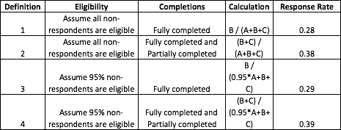

“COMPLETED” VS. “PARTIALLY COMPLETED” RESPONSES:

We excluded 62 partially completed surveys. Partially completed is defined as respondents who did not reach the end of the survey. This is because they either abandoned midway or were unable to complete the survey for unknown reasons.

COUNTING “PARTIALLY COMPLETED” RESPONSES & RESPONSE RATE CALCULATION:

We have considered ‘partially completed’ responses in 2 methods while calculating response rate as we have explained in the table above.

ELIGIBILITY OF NONRESPONDENTS:

Respondents qualified by virtue of being enrolled undergraduate or graduate students. We are assuming a 95% eligibility of non-respondents because some faculty members might have been reached by our survey as well, that counts to 5% of non-eligibility.

# 

# **III.D. DATA CLEANING**

DATA QUALITY AND DATA CLEANING POLICY:

We generally did not want to weigh heavily on results outside the bounds of simply resolving questions of unifying variables in format and measurement. The only exception to this was eliminating purposely subversive results that in no way fit the context of the question asked.

RESPONSE REMOVAL POLICY RULES:

**Conditions for disqualification of the respondent:**

* Removed where individual self-identified as ‘junk data’ i.e. Row 4 (professor Hogan’s),
* We eliminated individual responses by those clearly exploiting text boxes which follow ‘Other’ fields. An example is one person identifying their gender as ‘attack helicopter’
* Open text fields presented a challenge given the prevalent use of symbols such as dollar signs in the case of currency sum values. Using cleaning methods in python we assured uniformity/removal of these problematic symbols.

**Conditions for disqualification of individual answers:**

* We eliminated individual *responses* where textboxes required answers in numerical values, but we could not control for alphabetical responses.

**Conditions for modification of individual answers:**

* Range provided: In some textbox prompts individuals cited dollar ranges. In this case we resolved to use a *mean* of the two values to consolidate their answer into a single identifiable digit. Ex: ‘$400-600’.
* Lower/Upper Limits specified: Respondent accompanied digits with ‘less than’ or ‘around’. In these cases we have simply considered the digit associated at face value.
* Text/null value answers given in prompts for numerical ones are omitted

1. Content junk rows removed: 4,53, 68, 70 (Quantity: 4)
2. Redundant question/ID rows: 1,2 (Quantity: 2)

# **SECTION III.E. DATA ANALYSIS**

***Objective 1: Explore student preferences between retailers/platforms such as Amazon, Cengage etc. at a moment of industry-wide consolidation and declined textbook sales[2]***

(Question 1 v Question 2)

|  |  |  |  |  |
| --- | --- | --- | --- | --- |
| **What text materials do the students prefer?** | **Text Material Preferred** | | | |
| **Do you order text materials online?** | **Both** | **Digital materials** | **Printed materials** | **Grand Total** |
| No | 25 (41.67%) | 18 (30%) | 17 (28.33%) | 60 (100%) |
| Yes | 82 (51.25%) | 45 (28.13%) | 33 (20.63%) | 160 (100%) |
| **Grand Total** | **107 (48.64%)** | **63 (28.64%)** | **50 (22.73%)** | **220 (100%)** |

For understanding the relation between the students who buy text materials online or not and what kind of text materials they prefer, we compared the numbers of both the questions in the table above. To analyse the data, the null values were not included. On the crosstab, we also calculated the percentage of the row total. Most of the sample population indicated they preferred buying their text materials online. Out of the 160 respondents who agreed to order course materials online, 51.25% selected the option that they prefer both digital and printed materials. Since this option was chosen by a maximum number of respondents, it was evident that the respondents were opting in for both digital and printed books online.

(Question 4)

|  |  |  |
| --- | --- | --- |
| **Is it a Financial Stress to buy course materials?** | **Count** | **Percentage** |
| FALSE | 30 | 14% |
| TRUE | 190 | 86% |
| **Grand Total** | **220** | **100%** |

In this nominal question to determine if respondents feel any financial stress to purchase course materials, **86% of the respondents agreed** that purchasing of course materials is a **financial stress.**

(Question 5)

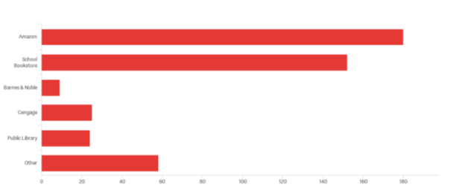

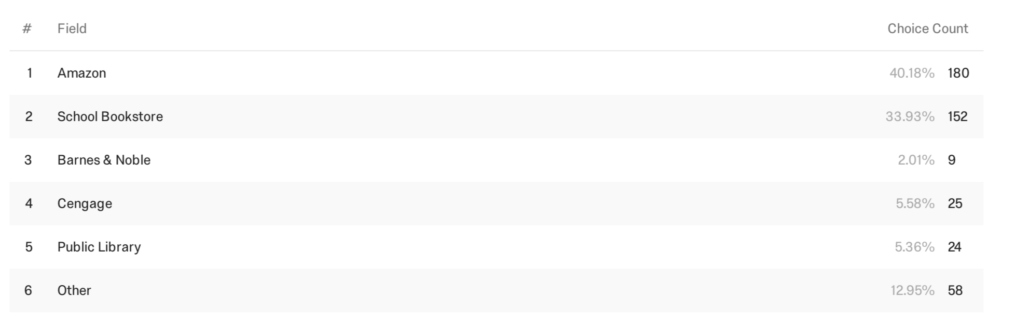

Based on the qualtrics analysis, the respondents showed the maximum preference for Amazon. Quantitatively, most of the respondents buy their course materials from **Amazon (40%)**, closely followed by the **UIC Bookstore (33.93%)**. Thus, the two biggest platforms that the respondents use for ordering their books are Amazon and the UIC Bookstore.

***Objective 2:*** *Understand base awareness level of Direct Access Program amongst students*

**The below question in our questionnaire caters to this objective:**

(Question 22)

Prior to taking this survey, had you ever heard of Direct Access Program by UIC Bookstore, which provides digital course material to undergraduate students?

o Yes

o No

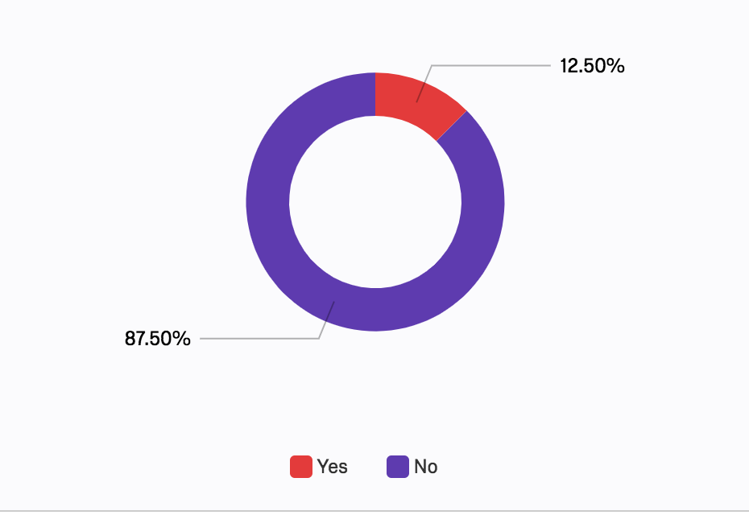

We can clearly see that most of the students (around 88%) have not heard about this program before, which means that the **awareness level is very low about this program**.

***Objective 3: Establish whether students prefer to opt into a monthly subscription for the Direct Access Program vs the industry-standard opt-out subscription model***

The questions below provide some insights about this objective:

Question 21(4)

To what extent do you agree with the following statements?

|  |  |  |  |  |  |  |  |
| --- | --- | --- | --- | --- | --- | --- | --- |
|  | Strongly disagree (1) | Disagree (2) | Somewhat disagree (3) | Neither agree nor disagree (4) | Somewhat agree (5) | Agree (6) | Strongly agree (7) |
| I think digital course material is expensive in general. | ▢ | ▢ | ▢ | ▢ | ▢ | ▢ | ▢ |

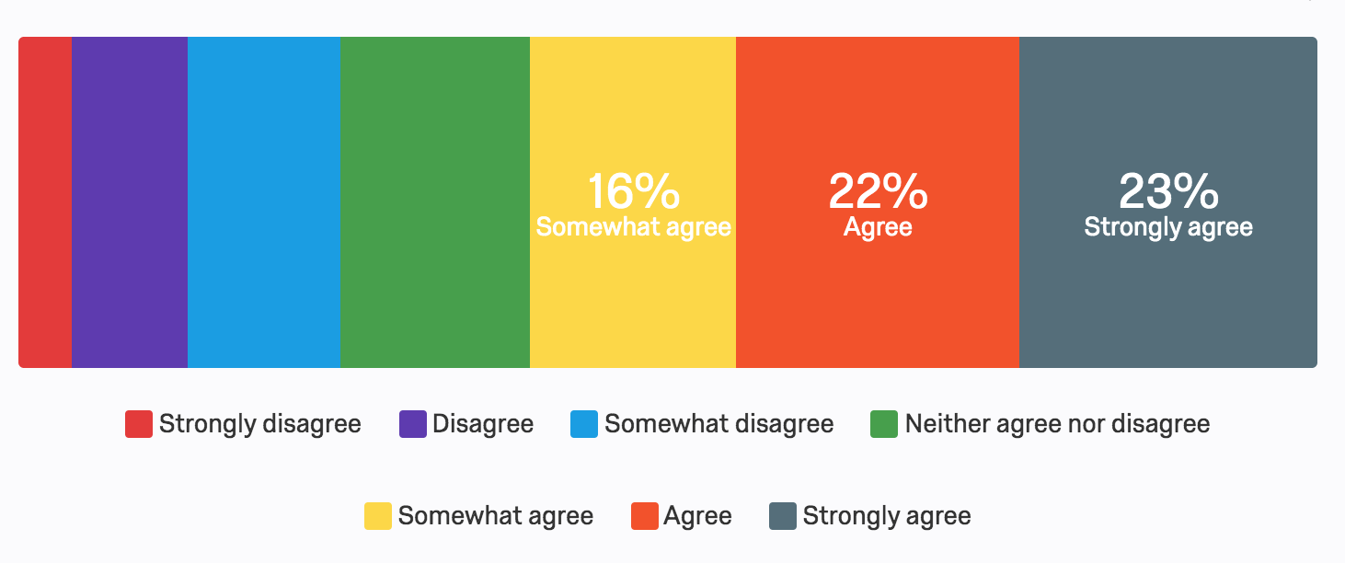

**61% of the sample agreed/have an inclination to agree** with the statement that **digital course material is expensive**, which means that students will not choose to go with one when given a chance to select between digital and paper text material.

Question 21(5)

To what extent do you agree with the following statements?

“I go with the cheapest option when I purchase any course material”

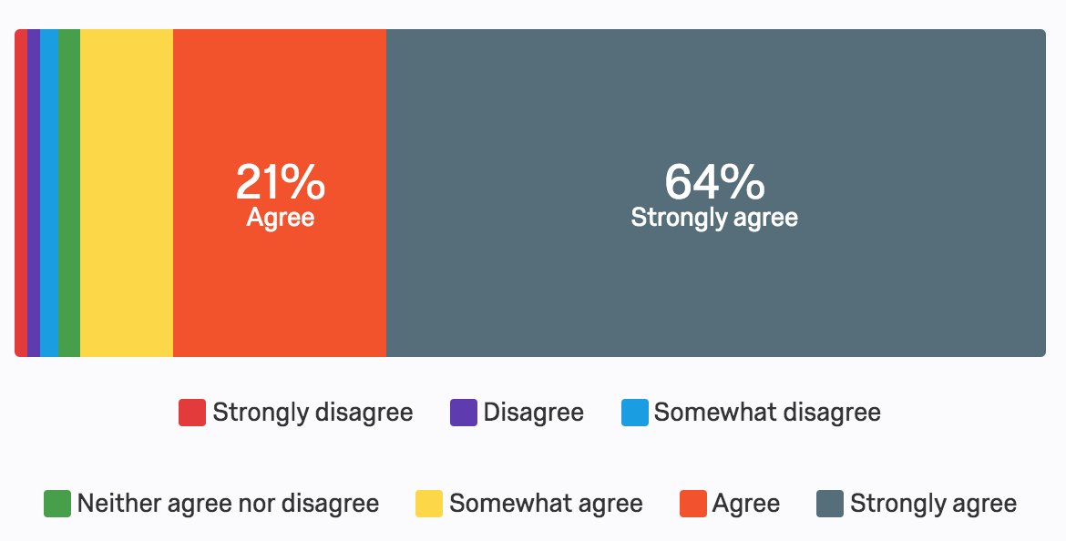

**64% of sample strongly agree** that they go with the **cheapest option available**, and around 94% (Somewhat agree-9%, Agree- 21%, Strongly Agree- 64%) agreed with this statement at some level, which proves that it’s important for UIC Bookstore **to consider changing the perception of students about digital course material that it’s expensive**.

Q23 How likely would you opt for Direct Access Program (digital course material) by UIC Bookstore if you can access it at the most affordable cost compared to other course materials?

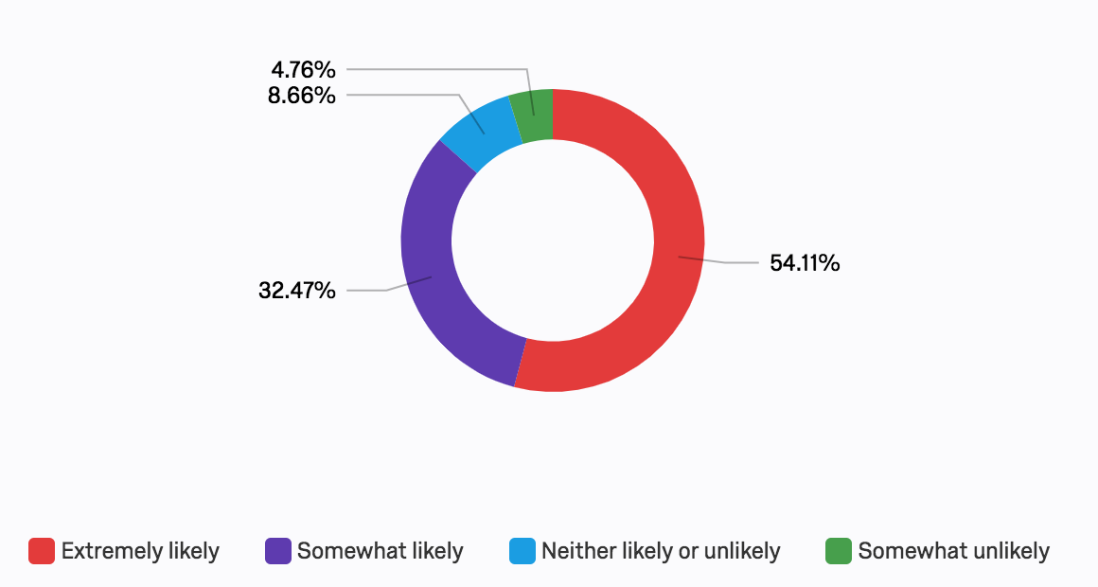

The answer to this question clearly suggests that students are **willing to opt in for Direct Access Program** if they get it at the most **affordable cost.** **Around 87% of sample students selected ‘Extremely likely’ or ‘Somewhat likely’ for this question**, which indicates that UIC Bookstore has to be competitive with the market in terms of pricing of its course material. Also, ‘Extremely likely’ itself constitutes more than half of the population targeted, which is definitely going with DAP given the costing is right.

(Question 25)

Have you ever heard of a program like the Direct Access Program at other schools?

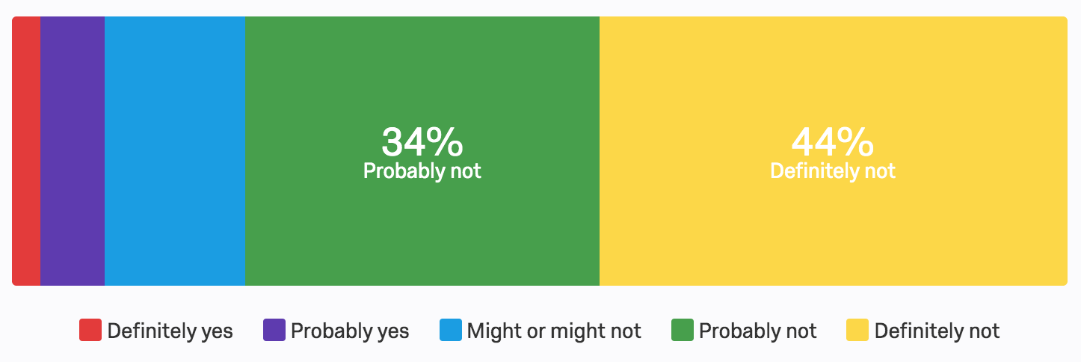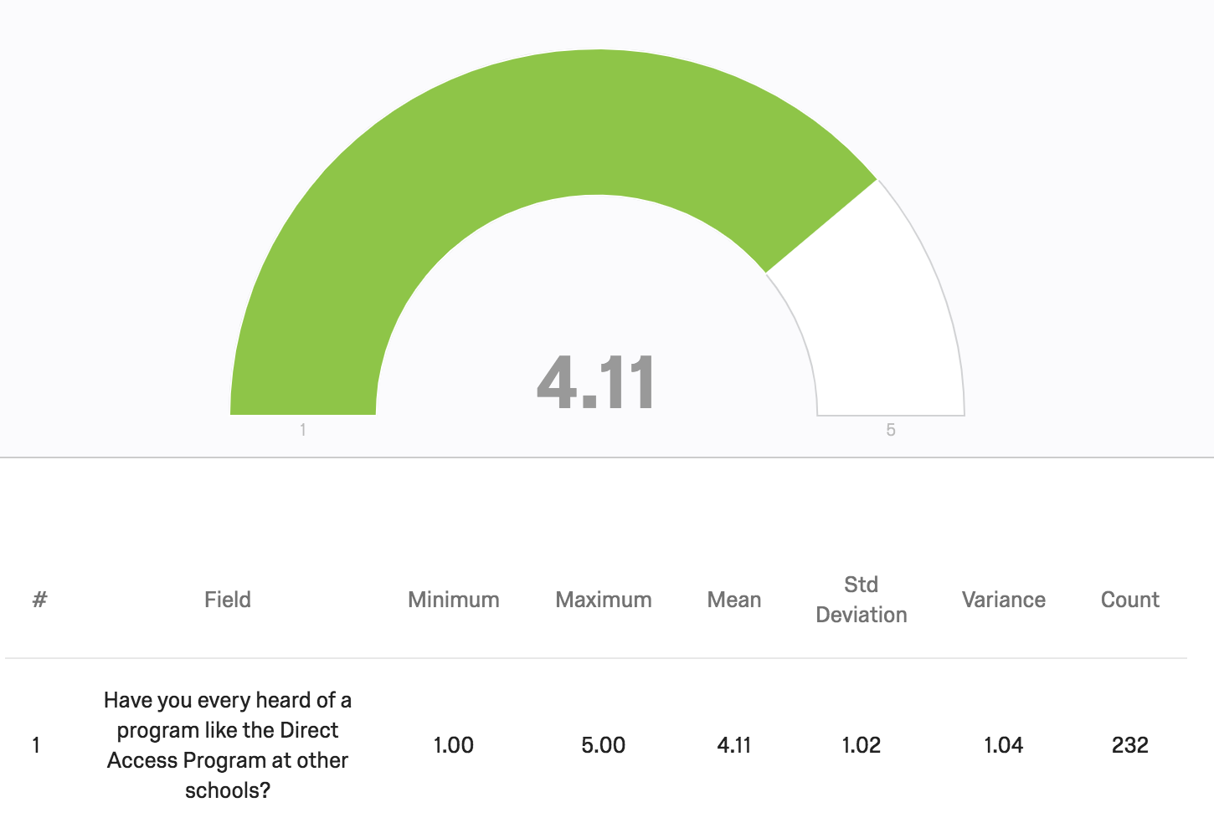

Above two charts clearly point to the understanding that students haven’t heard of such programs at other universities or colleges. Around 78% of the sample population selected ‘Probably not’ or ‘Definitely not’ when they were asked whether they’ve ever heard of such programs like Direct Access in other universities. Mean value of 4.11 with 1.02 standard deviation also indicates the same understanding.

After analysing answers to these 4 questions, UIC Bookstore should understand that students are willing to opt in for such programs if they get their course material at affordable cost. Also, digital material is relatively affordable as compared to the physical books, but students think the opposite.

*Objective 4: Determine preferred avenues of communication for promotion amongst students*

Q15 - Would you like to hear about offers on course materials?

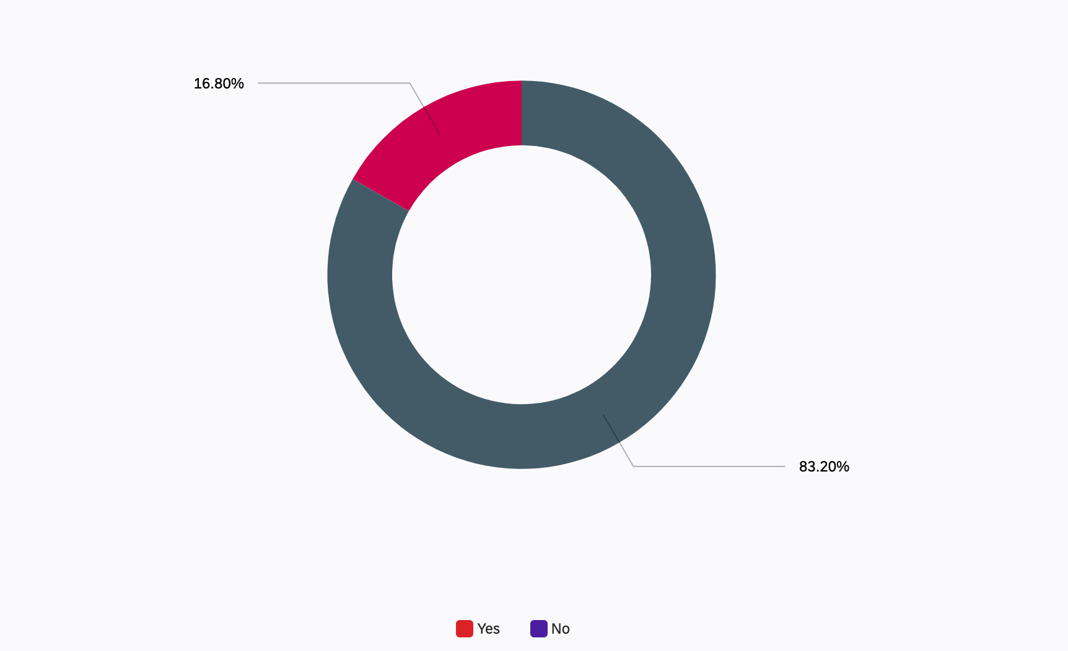

83.2 % students want to hear about offers.

Now let's look at what are their preferred avenues for communication

Q16 - Please rank where you would prefer hearing about promotional offers the most: (1-most preferable; 5- least preferable):

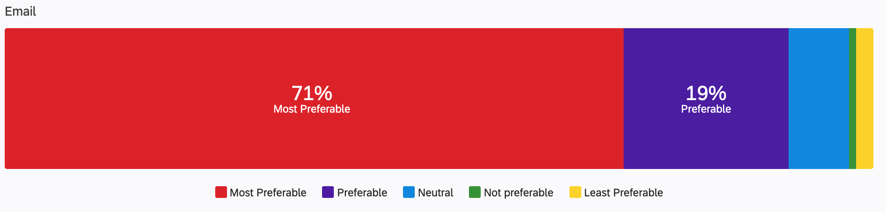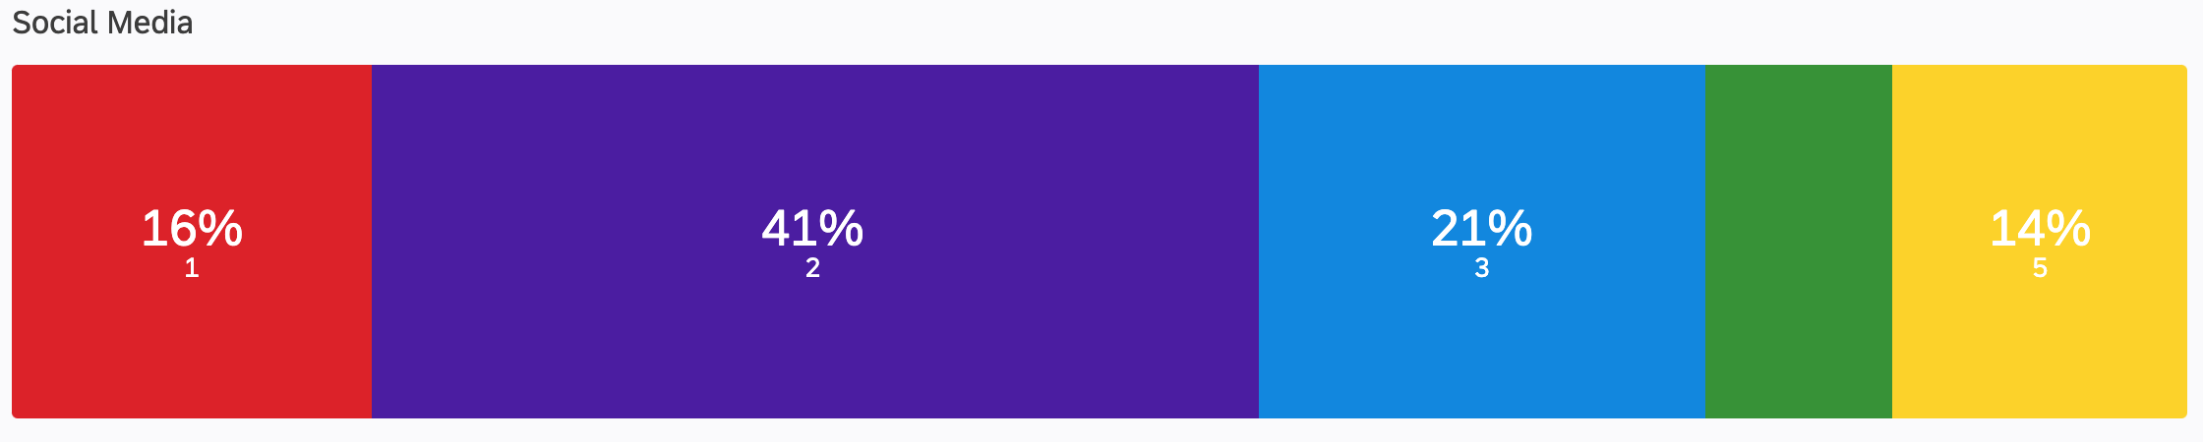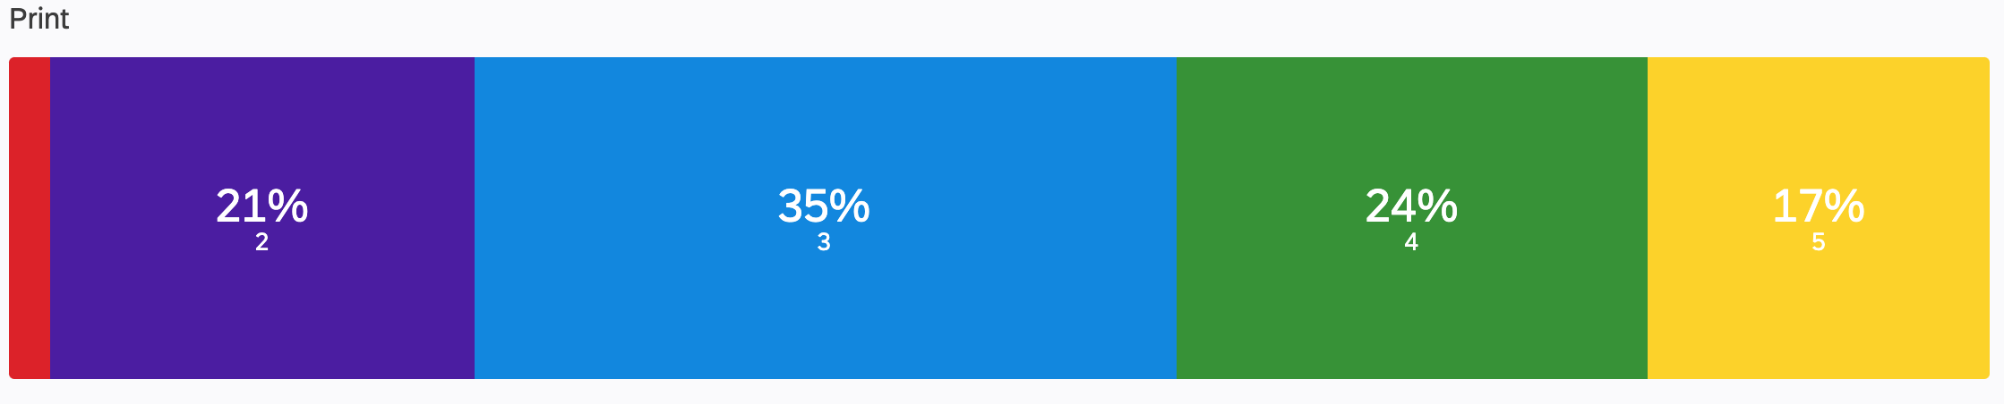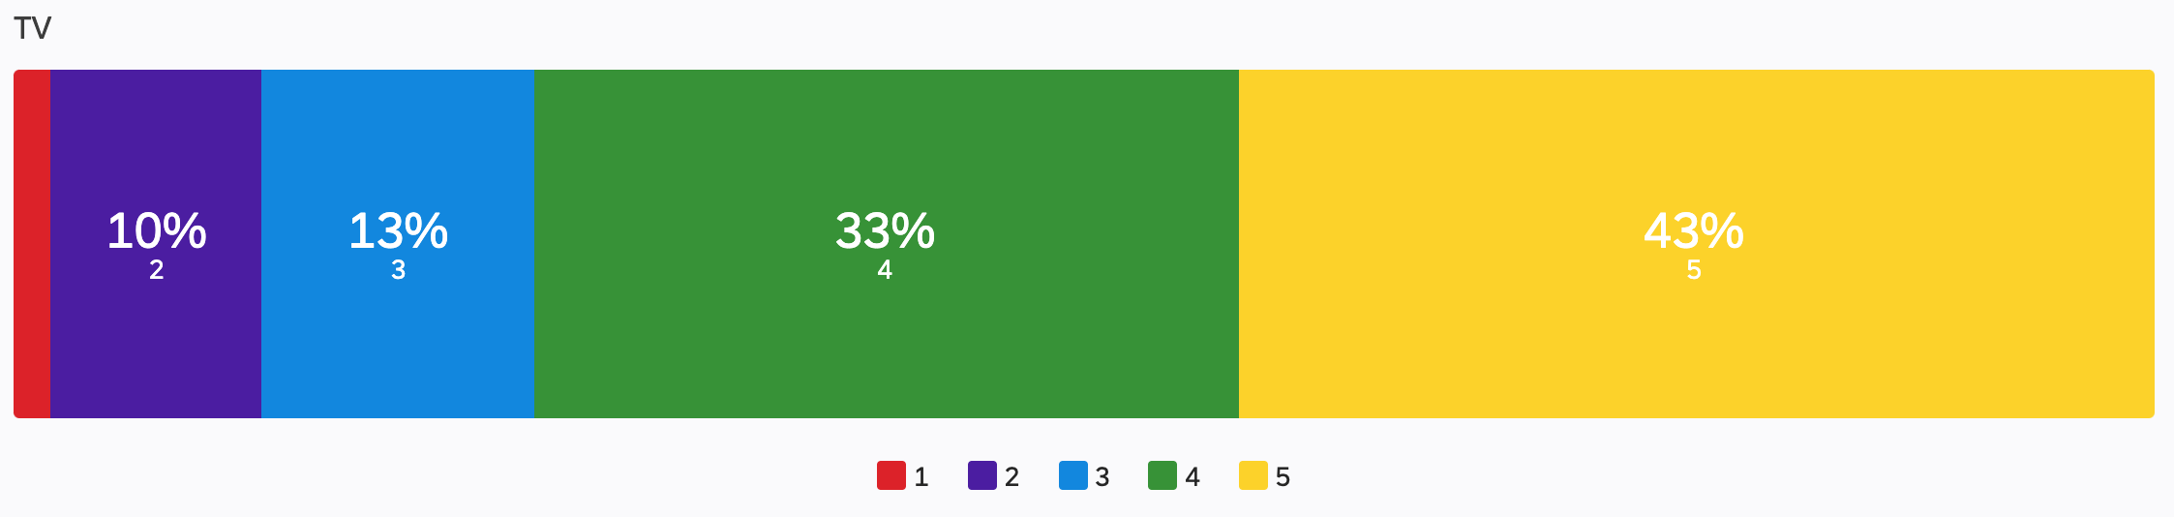

What we observe is a strong preference for Email and Social media avenues like Facebook/instagram to be used for communicating promotional offers for DAP

Q17 - Which social media platform do you use the most?:

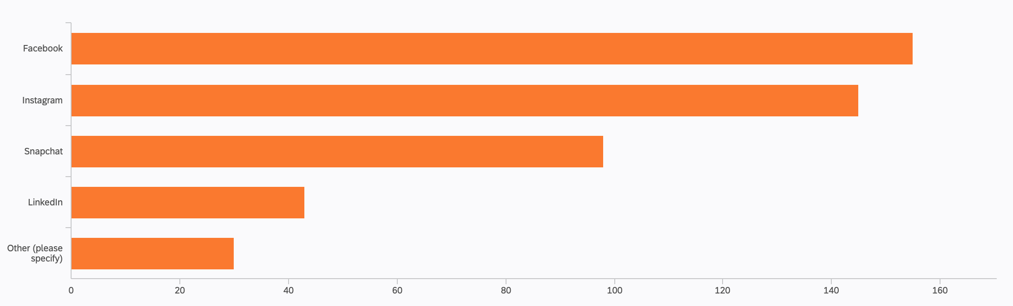

Facebook and Instagram seem to stand out the most.

***Objective 5: Identify obstacles in conveying a value proposition to students (from the point of view of students).***

The main obstacles would be affordability or not having the necessary collection of books. To understand these, we intend to analyse the prices and the quantity/mix of course materials.

(from the point of view of students).

Conversations about college affordability tend to focus on tuition, and with good reason — the cost of attending college in the US increased 63 percent between 2006 and 2016, according to a report by [the Bureau of Labor Statistics](https://www.bls.gov/opub/ted/2016/college-tuition-and-fees-increase-63-percent-since-january-2006.htm). Compared to tuition, which can cost out-of-state students at public universities [as much as $26,000 per year](https://trends.collegeboard.org/college-pricing/figures-tables/2018-19-state-tuition-and-fees-public-four-year-institutions-state-and-five-year-percentage) or upward of $40,000 at some private colleges, the amount of money students spend on things like textbooks can seem negligible.

But the price of textbooks has similarly skyrocketed over the past decade: Textbook costs increased 88 percent between 2006 and 2016, according to the BLS report. The College Board [suggests](https://trends.collegeboard.org/college-pricing/figures-tables/average-estimated-undergraduate-budgets-2018-19) that students set aside $1,200 each year for books and other course materials, which can be an exorbitant amount of money for students who come from low-income backgrounds.

**This story isn’t much different for students of UIC. We took the following steps to address this objective:**

1. Understand the prices students are paying versus how much they should be spending? Is there a relationship? Confirm with a correlation test.
2. Understand if the prices they are paying are a financial burden to them or not? We selected Q14 as to what they feel about the prices of course materials to understand this point. Confirm this with a hypothesis
3. Understand how satisfied students are with the current prices of bookstores. Is there a relationship between the price they are paying and satisfaction levels?
4. Understand if students are satisfied with the quantity of books offered

**Results of this section are further analysed and investigated in Section IV**

*Objective 6: To identify how the information defined from the previous statements varies according to the characteristics of college students, including gender, class standing, graduate or undergraduate, type of course structure, major of study, and in-state vs. out of state.*

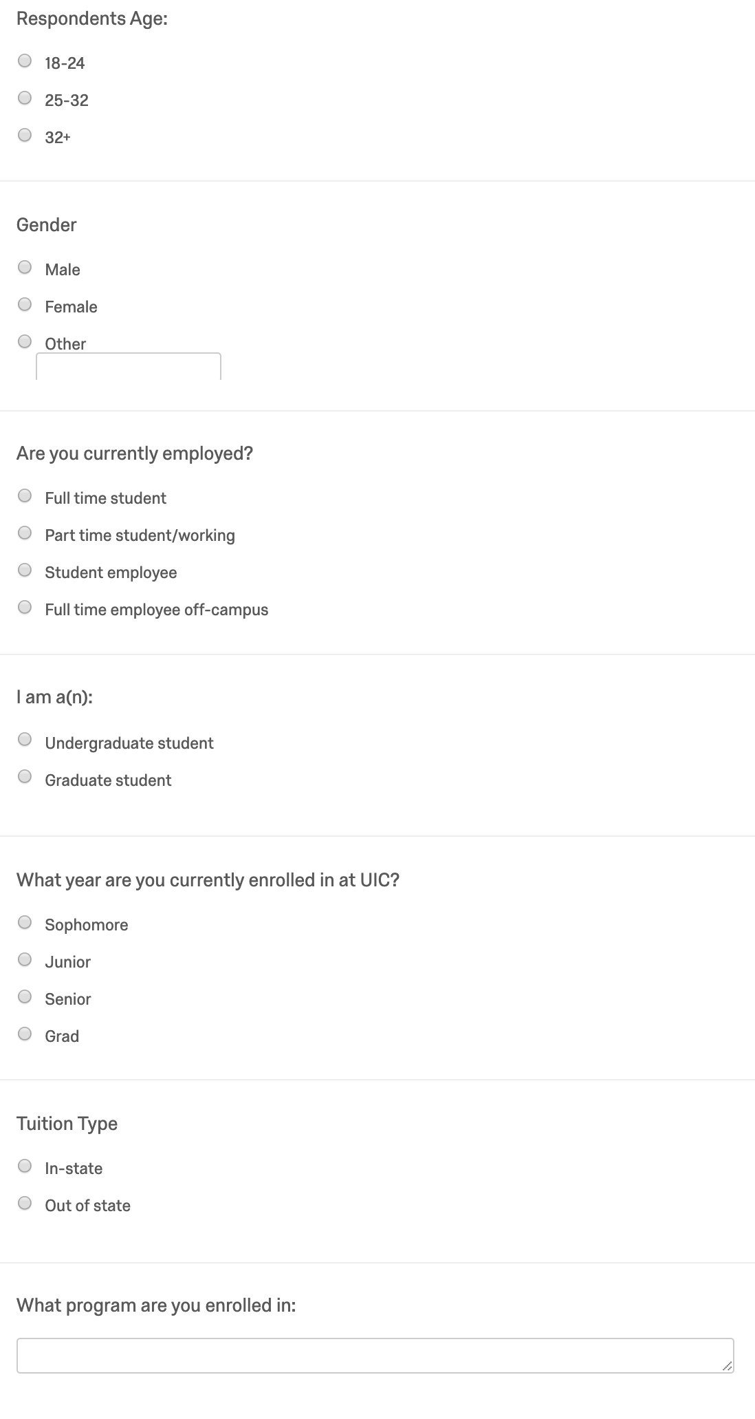

These demographic questions helped us define each of the characteristics of each respondent from the following: age, gender, employment, undergraduate/graduate status, grade level, and residency status. Using the multiple choice questionnaire and free-response section, we were able to collect demographic information from the respondents.

Age: Majority of the survey respondents were 18-24 (~ 80.97%), followed by 25-32 (~16.37%) and 32+ (~2.65%).

Gender: Majority of the survey respondents were female (~66.37%), followed by males (~30.97%) and other (~2.65%).

Employment: Majority of the survey respondents were full time students (~52.97%), followed by part time student/working (~20.55%), student employee (~19.63%), full-time employee off-campus (~6.85%).

Undergraduate/graduate status: Majority of the survey respondents are undergraduate students (~75.11%), followed by graduate students (~28.89%).

Grade level: Majority of the survey respondents were sophomores (~25.94%), followed by graduate (~25.11%), junior (~24.66%), and senior (~23.29%).

Residency status: Majority of the survey respondents were in-state tuition students (~80.80%), followed by out of state (~19.20%).

# 

# **SECTION IV. RESULTS**

## **Objective 1:**

Based on the data analysis conducted for Objective 1, we see that there is a higher number of students who prefer buying their course materials online. 76.6% of the students out of the 107 students preferred to buy their course materials online. Given the demographic who were reached out as students at the UIC campus, it is logical to see a substantial increase in the number of online users. Among the online buyers, 51.25% of students responded saying that they prefer buying both printed and digital course materials and not just digital course materials. This is crucial as it shows the trend of hard copied books still being used as compared to e-books, when it comes to academic course material. Students have indicated a considerable financial stress when it comes to purchasing course materials. 86% of the students agreed that it is a financial stress to buy course materials. Given this information, we saw that students preferred Amazon (40% of the students) as the most popular retail platform to buy course materials. The UIC bookstore (33% of the students) is a close second. Thus, there is a clear preference for students that Amazon is their most preferred platform to gain access to both printed and online versions of course materials.

**Objective 2: (Question 22)**

Majority of the students have not heard about Direct Access Program before taking this survey, which means that the awareness level is very low about this program, and UIC Bookstore needs to take some actions in order to build awareness.

**Objective 3: (Questions 21(4), 21(5), 23, 25)**

Our research suggests that students are willing to opt in for such programs if they get their course material at affordable cost. Also, digital material is relatively affordable as compared to the physical books, but students think the opposite.

## **Objective 4: 8, 9, 12(a), 12(b), 12(c), 15, Demographic (7)**

Professors face the undue burden of shepherding students through a consumer decision in an effort to seamlessly tie the semester’s activity in with syllabus. Students were overwhelmingly in favor of professors stepping outside the traditional bounds of their role in order to outright promote specific learning platforms and content. It is clear from our data collection that students place a substantial weight on what their professors recommend. This is confirmed by the student timeline for buying books, which manifests in a hesitation to buy books in advance. The purchase of books is largely reserved for once they are equipped with the syllabus after a first meeting, rather than in the days/weeks before class commences. Our data indicates that students very much wait until a week or two into the class to be sure about their purchase. Thus, as the figure indicates below, digital promotion of a digital platform is compelling, actionable and falls within the timeline of student purchases via the Direct Access Program.

## 

## Staff Promotion (Question 15, Question 24)

(a) (b)

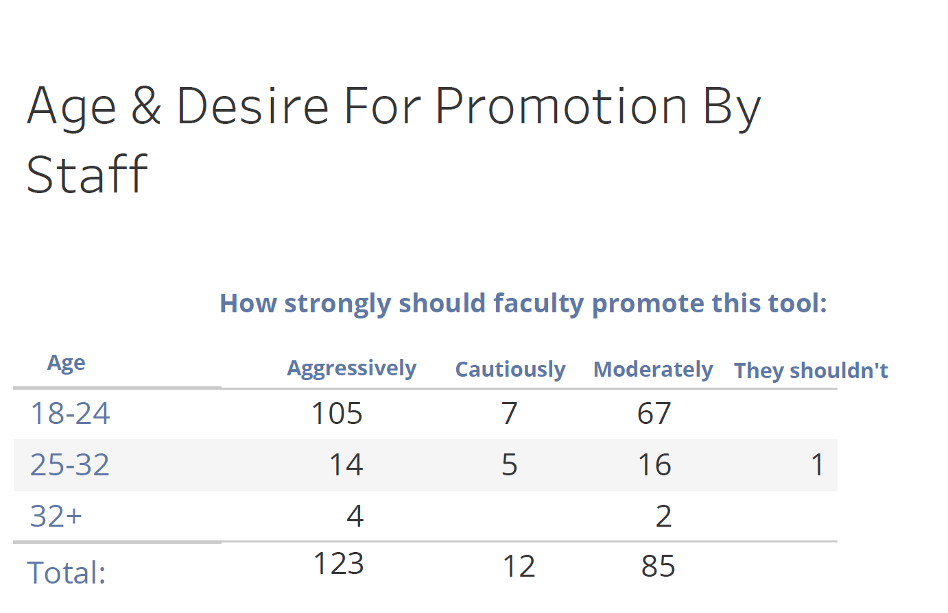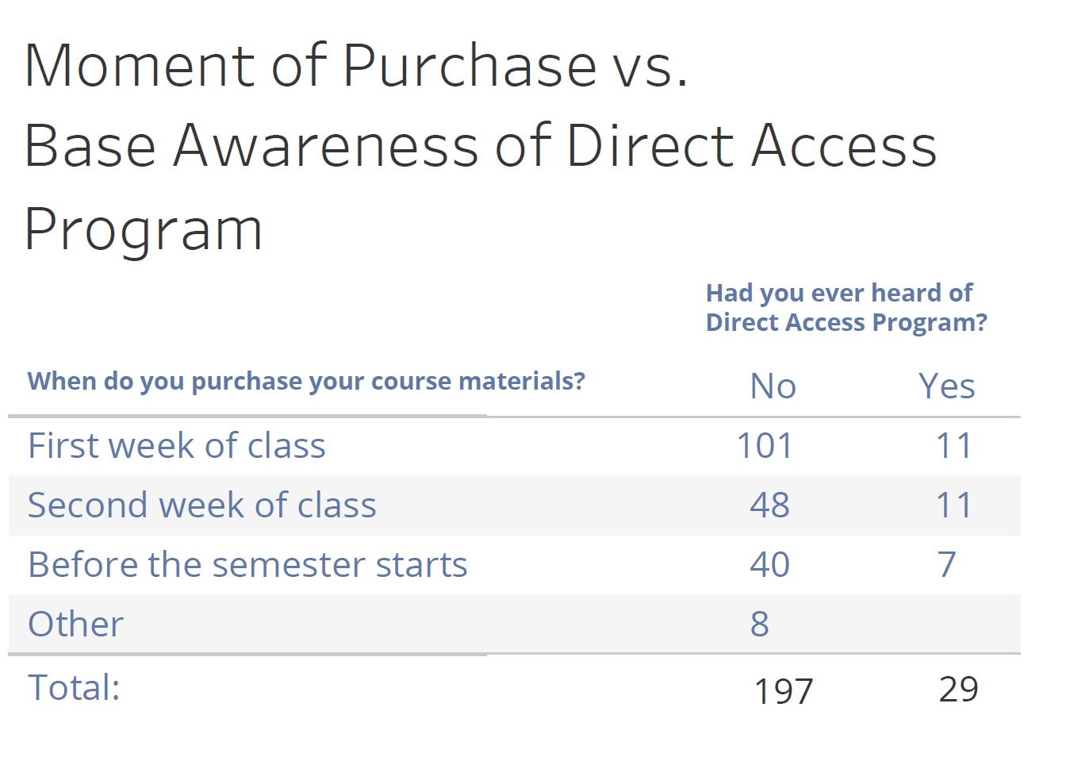

|  |  |  |  |  |  |  |  |
| --- | --- | --- | --- | --- | --- | --- | --- |
| The younger the respondent, the stronger the desire to have a professor expose them to a promotion  1. The bulk of respondents wait until class has started to purchase books. Most of these individuals have not heard of the Direct Access program  (c) Crosstabulation: Question 15 * Question 24 (c) The cross tabulation below displays the relationship between eagerness to hear about offers on course materials (Question 15) and how strongly faculty should promote the Direct Access Program (Question 24). | | | | | | | |
|  | | | | | | | |
|  | | **How strongly should faculty promote this tool:** | | | |  | Total |
|  | Aggressively | Moderately | Cautiously | They shouldn't |
| Would you like to hear about offers on course materials? |  | 49 | 0 | 0 | 3% | 0 | 50 |
| No | 3 | 3% | 8% | 1% | 3% | 40 |
| Yes | 13 | 40% | 22% | 31% | 0% | 203 |
| Total | | 65 | 126 | 88 | 13 | 1 | 293 |

#### Note: There is an overwhelmingly statistical significance as expressed in the very low p-value of 0.0003465 which results from our chi-squared test. We reject our null hypothesis as we remain under the alpha value of .05 while operating under 95% certainty.

#### (d) Cross Tabulation: Question 12 * Question 22

The cross tabulation below displays the relationship between whether a respondent has tried digital alternatives for course materials (Question 12) and whether the respondent has ever heard of a program like the Direct Access Program by UIC (Question 22). The goal is to assert a benchmark for promotional campaigning. The resulting assertion is that students both have experience with digital materials, and are aware of equivalent offerings in other schools. We can infer that our major preoccupation in result in the pitfall of base awareness for the Direct Access Program is predicated on the UIC Bookstore’s promotion of its own solution.

(d)

**Have you ever heard of a program like**

**the Direct Access Program at other schools?**

|  |  |  |  |  |
| --- | --- | --- | --- | --- |
|  | | Null | Yes | No |
| **Have you tried digital alternatives for course materials before?:** | No | .3% | 6% | .7% |
| Yes | 5% | 62% | 9.2% |
| Total | | 65 | 199 | 29 |

Note: Despite overlap between students who have tried digital course materials and those aware of equivalent programs at other schools, we failed to reject our null hypothesis as the p-value is greater than the alpha level of 0.05. In other words, there is no statistical relationship between students having tried digital course materials and whether they’ve heard about equivalent offerings at other schools. Question 23 served as a dependent variable which posits whether a student will buy the Direct Access Subscription or not based on this relationship.

(x-squared = 0.81807, df = 1, p-value = 0.3657)

(e)

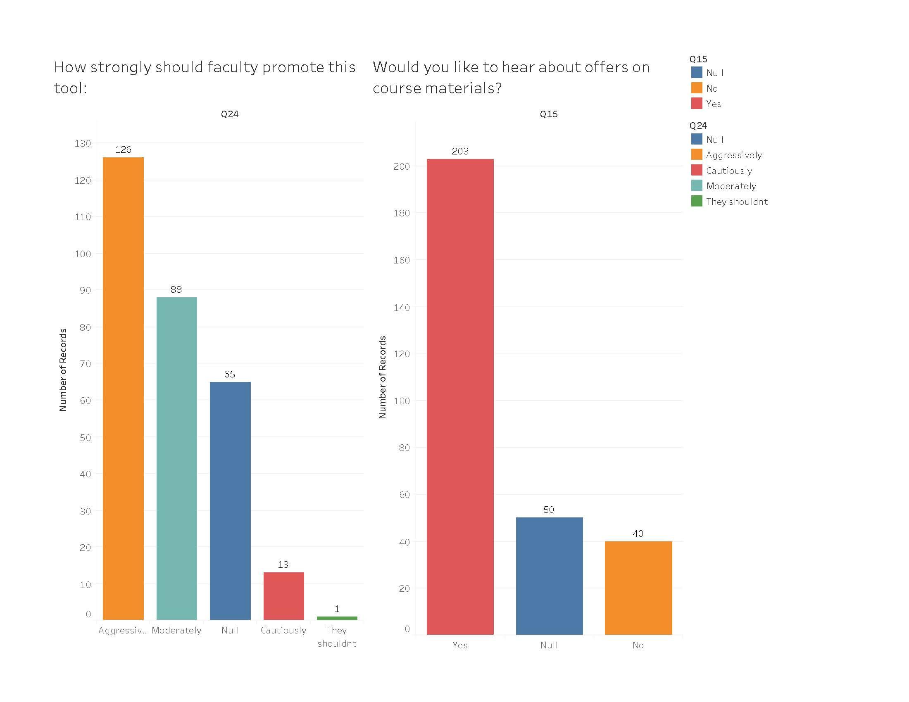

### Legacy Promotional Channels *(Question 16)*

As seen in figure (f) below, of 233 respondents, students overwhelmingly expressed that email was singularly the most effective way in which they learn about promotions. Despite the progress of more novel digital channels, there is an evident inclination for students to defer to bulk communications via email when it comes to receiving actionable news via formal school lists (which rank first at 73% of all results). This is good news for the bookstore and school at large because this is essentially a captive audience given the legacy of the mass e-mail medium. However, it should be noted that there is a high probability that UIC Bookstore would benefit from widening the scope of its communication by establishing its own list in addition to the prevailing convention of their content being included in other topical newsletters of departments.

Print advertising has proven remarkably resilient, particularly in a closed ecosystem such as UIC campus. Despite being a static (versus tailored) medium once executed, it plays an integral part of the media mix for students based on the figure below. While its influence cascades into lower rankings (in blue), it maintains a large volume. While the bookstore may operate under the assumption that this is a channel best reserved for campus, a limitation is that our findings do not distinguish between whether print advertisement are geofenced or aimed at the UIC student body at large while commuting in the metro market (i.e. CTA stops).

(f)

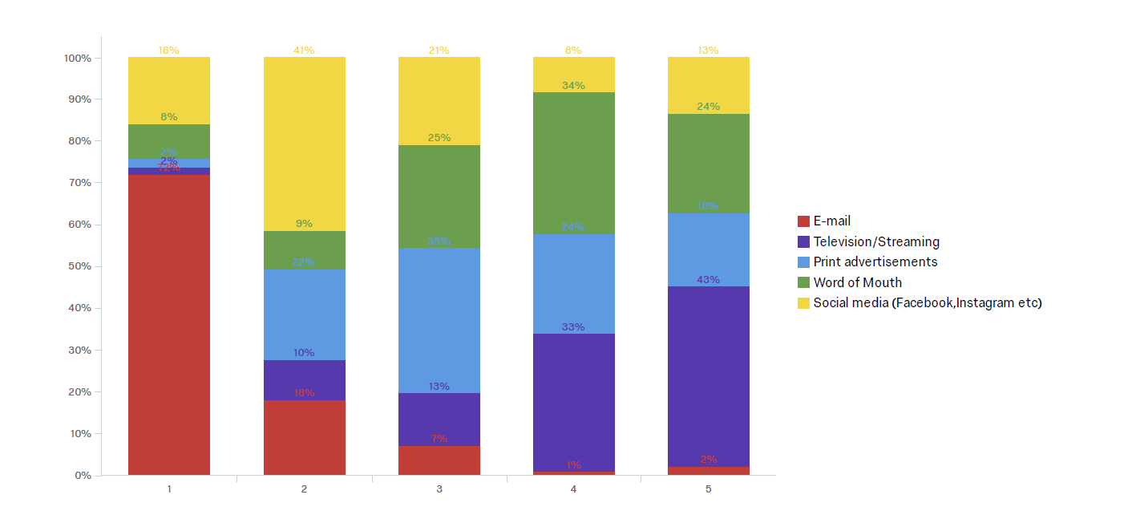

### (x-axis) above represents an ordinal ranking scale across 5 points.

### 

### Digital Advertising & Social Media Preferences *(Question 17)*

There is an increasingly pronounced student eagerness to be reached via display ads on streaming/television, although it is not top ranked in the figure above. It is still creeping in prevalence and could emerge in importance as indicated by the large blocks which are reverse-tapered in the figure. This avenue is defined by targeting, rather than conventional ad buys that are ‘set it and forget it’. Although potentially a cost-intensive channel for the UIC Bookstore, one cannot overstate the potential to leverage display ads. The good news is that unlike conventional advertising, it can be continually modulated and revisited in terms of budgeting. Streaming video use is extremely prevalent on campus networks, with students accessing YouTube for leisure and reference. A corresponding Google AdWords display ad campaign would be best executed within this context by using geofencing and/or IP targeting. This can be done to target students not just on campus, but in residence halls in the general vicinity around campus.

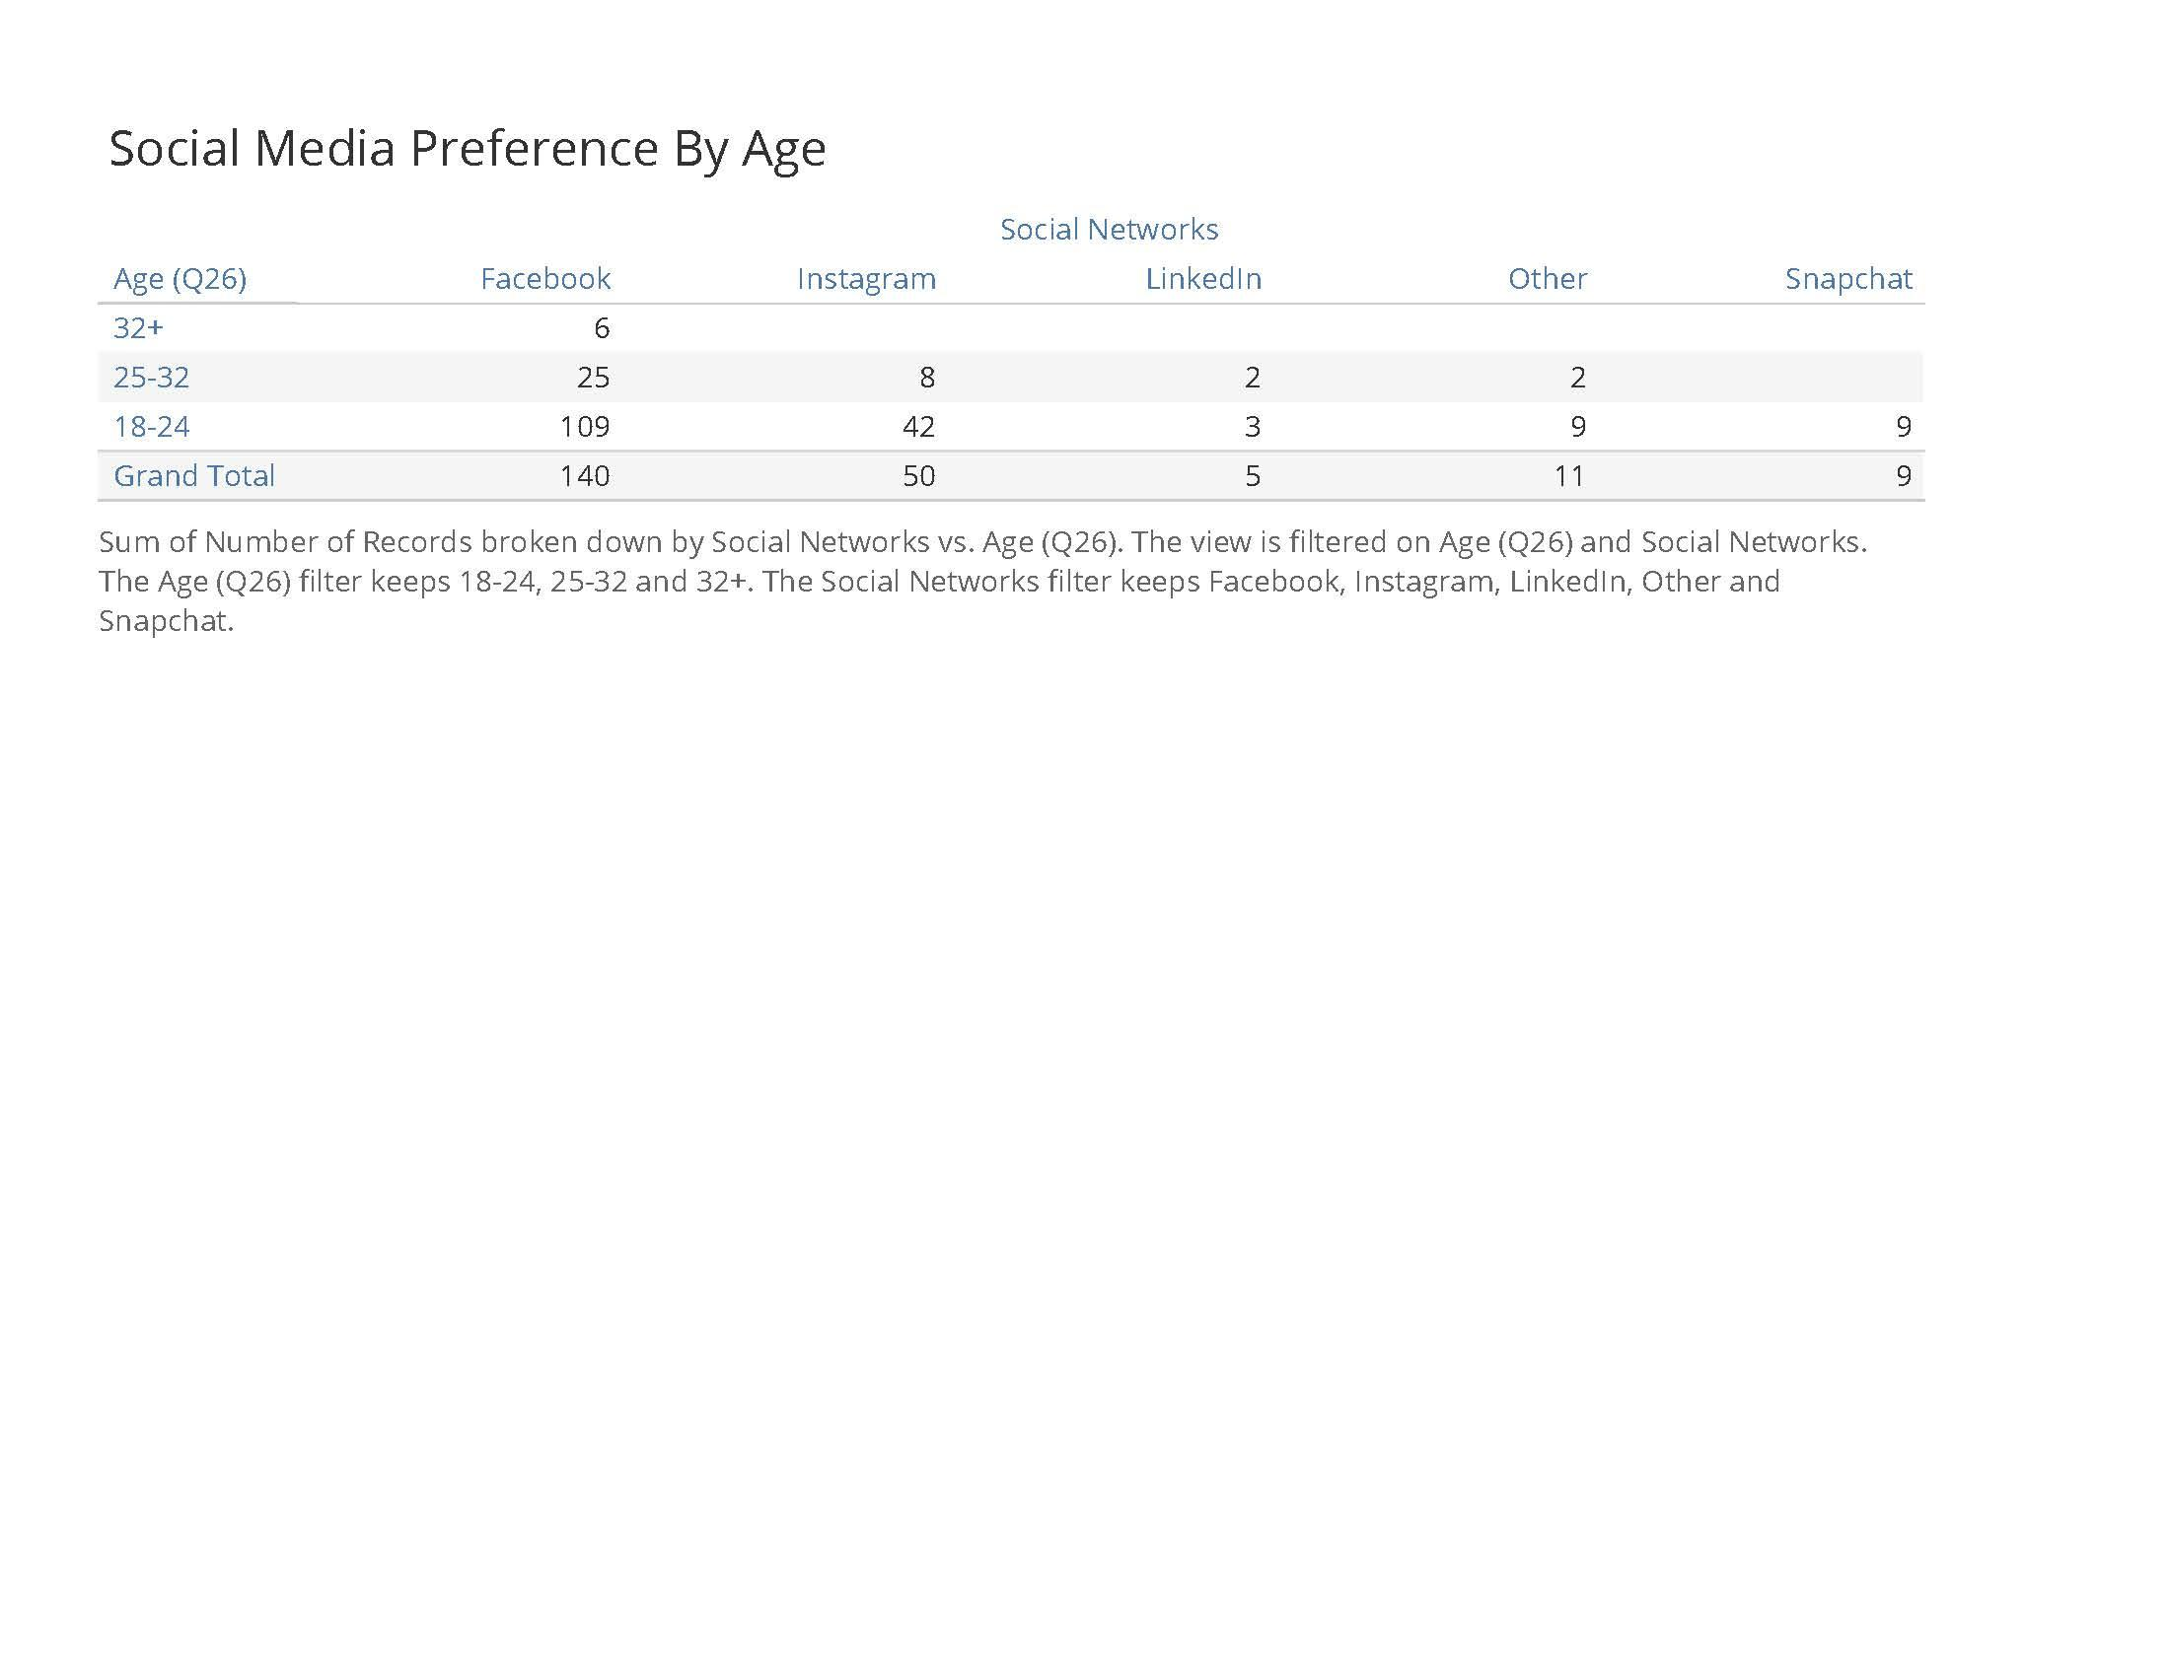

When pivoting to social media use, Facebook still reigns as the single most ubiquitous social networking force when it comes to our population at 32% (complemented by an impressive .69 in variance). However, it should be noted that Instagram follows very closely at 23%. This means that two networks within the Facebook portfolio are valuable promotion channels. This potentially simplifies UIC Bookstore’s ad buy strategy, while simultaneously telling it where to allocate its budget. An interesting emergent platform is Snapchat. Even though largely written off by millennials and older, it should at least be considered as part of the web ad mix in reaching Gen Z as indicated in the figure above.

It should be noted that despite healthy representation by the UIC student body for networking purposes, LinkedIn is not a venue in which students seek out information on tools instrumental to their academic life. In this sense, our data points to a conscious delineation between professional versus academic expressions on social media, as evidenced by a paltry 8% of whom turn to LinkedIn to learn about promotions. Similarly, neither Reddit or Twitter factored as platforms conducive for promotion of academic tools.

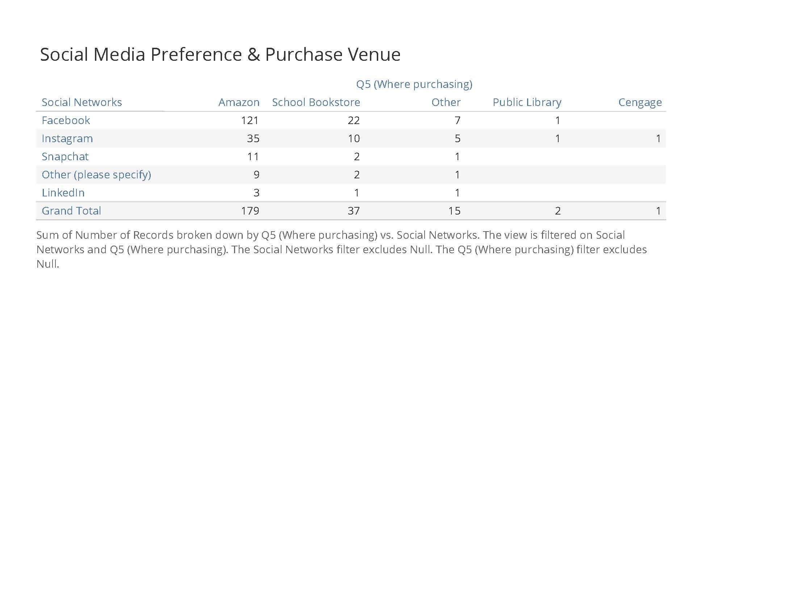

The figure above serves to shore up the assumption that there is a tremendous amount of crossover between users of social media communities and Amazon shoppers. This is due to (a) ease of transaction combined with the (b) prevalence of Amazon network’s advertising environment.

## **Objective 5:**

Our survey collected data on how much students are spending on an average 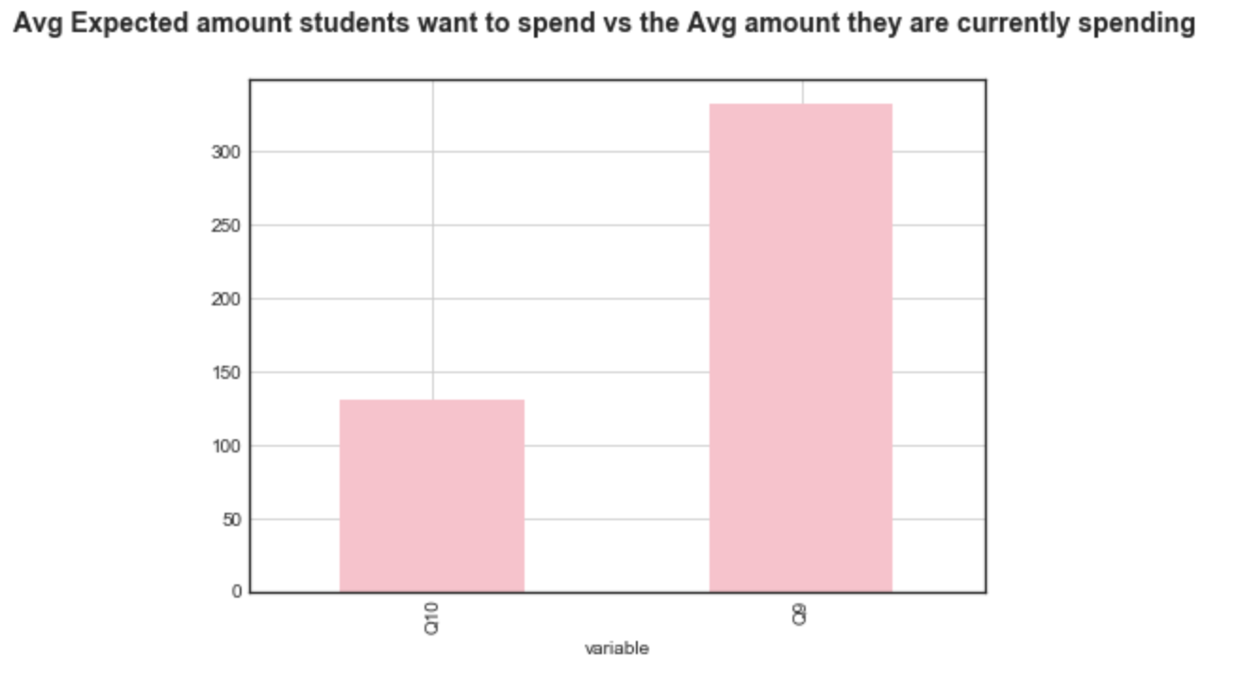

So we’re at a point now where, on average, for a semester, taking a full course load, the students are spending around $333.13 dollars

On asking students how much they would prefer spending, a clear difference can be observed. **They wish to spend an average of $131 dollars**

We can also use boxplots to visual the distribution of these responses

Q9 : Amount students are currently spending

Q10: Amount students are willing to spend

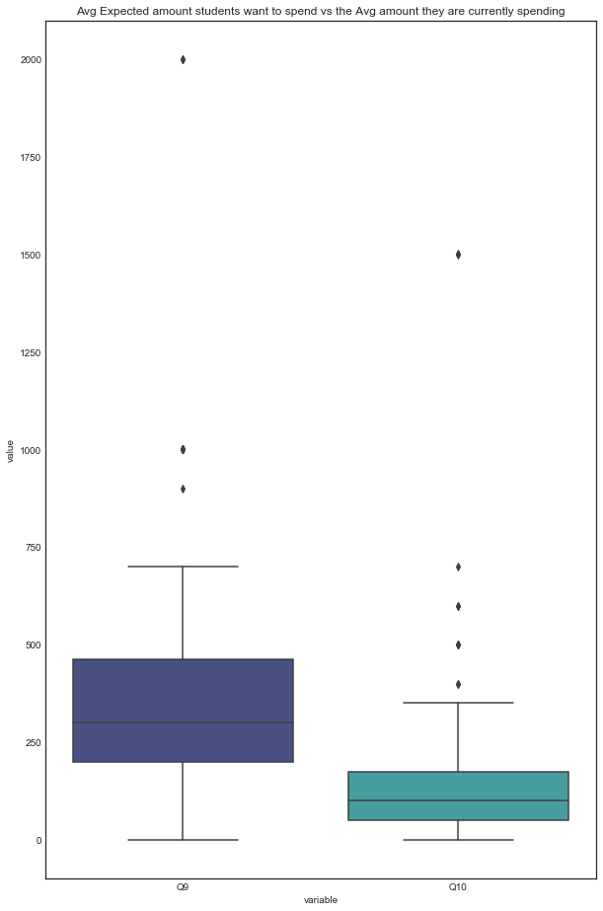

Pearson’s Correlation Test :

Q9 - Dollars students are spending currently

Q10 - Dollars students wish to spend

.

Looks like a positive correlation

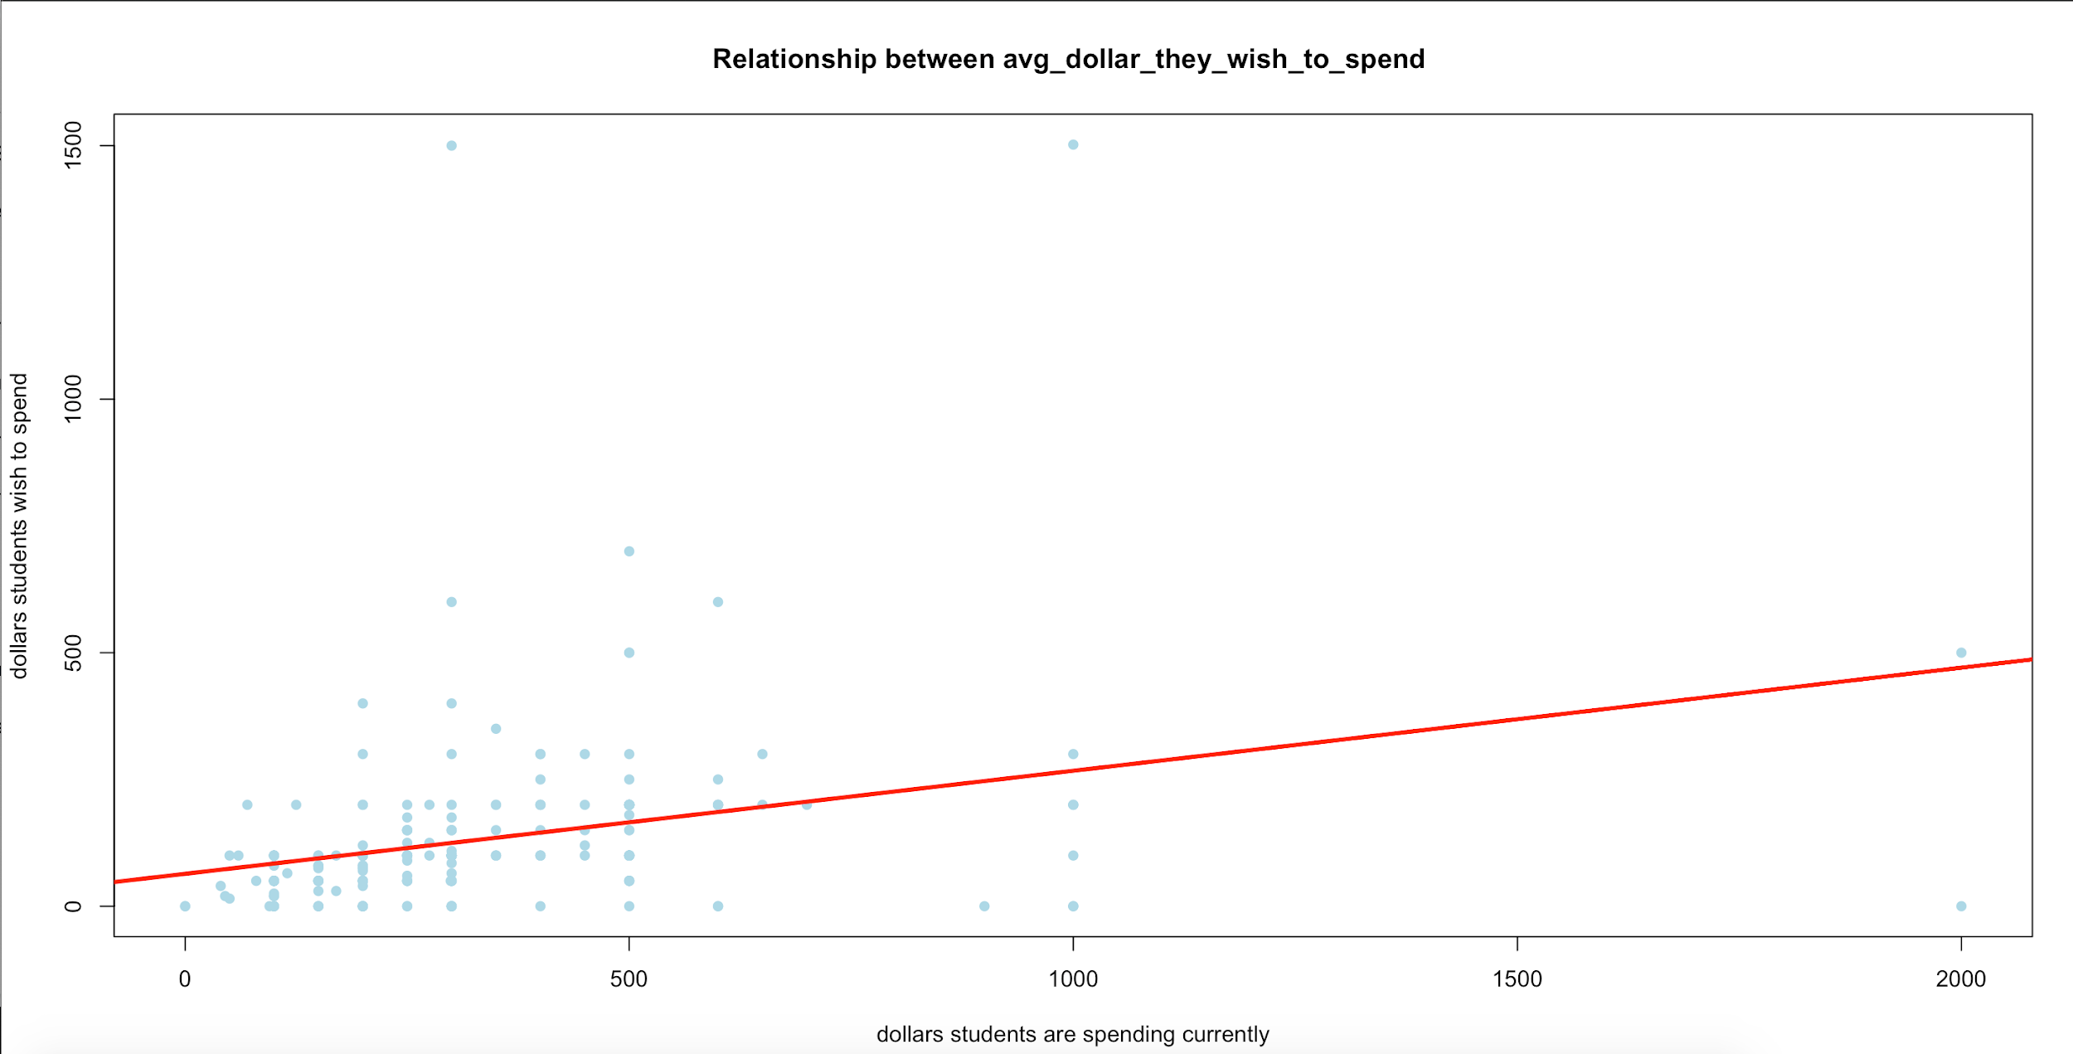

*R code Correlation test*

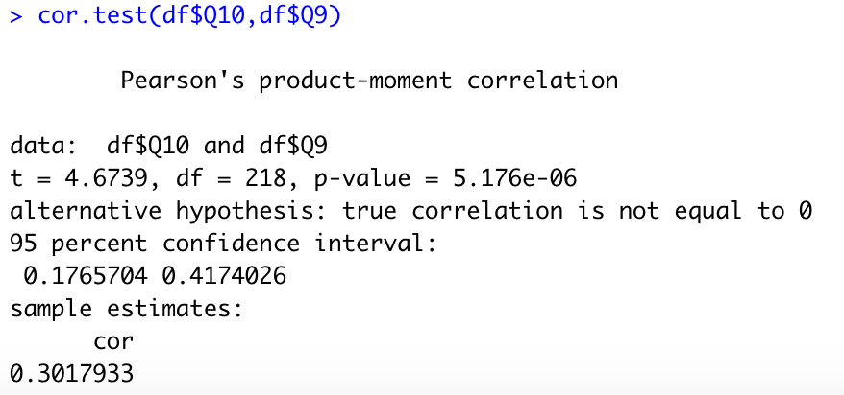

Dollars students are spending currently is Positively Correlated to the amount they desire to spend (0.3017).

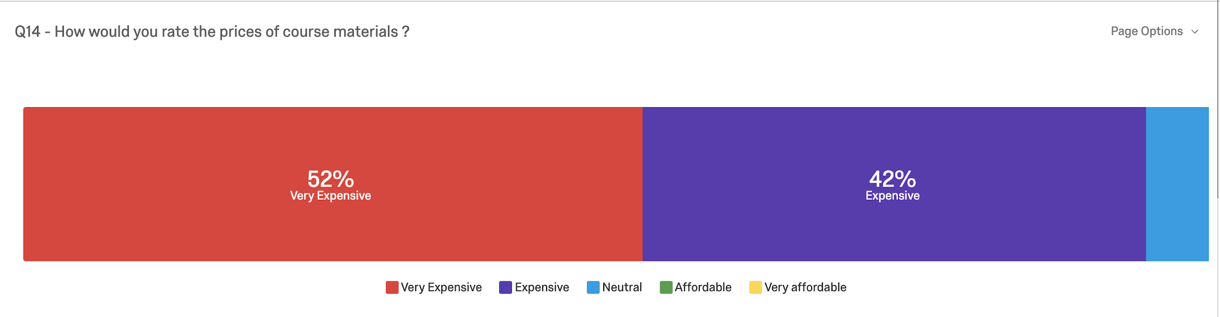

When students were asked about how they would rate the prices of course material, 52% stated these were very expensive. On examining how much these students are paying in terms of dollar value the following table illustrates a clear picture:

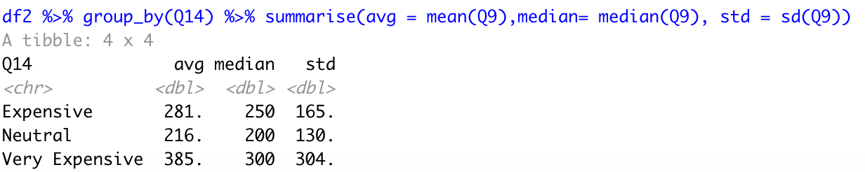

An anova test would would confirm this relation

Anova Test

Q9 - amount they are spending currently - numeric variable

Q14 - how would you rate the prices of course materials is factor hence Anova test

Ho = No relationship between Q9 and Q14

Ha = There is a relationship between Q9 and Q14

Output : p value observed is 0.00229

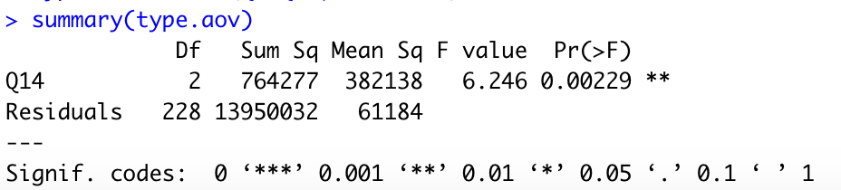

We reject the null hypothesis because the p-value is smaller than the alpha level of 0.05. In other words, there's a statistical relationship between amount students are spending currently and how would they rate the prices of course materials.

This solidifies our judgement about the current prices of course materials being a financial burden to students these days.

We can also take this up a notch and look at would would be the ideal prices they would want to spend based on what they feel:-

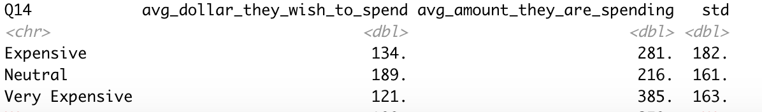

Let’s look at what students have to say about the prices at the bookstore.

To understand how satisfied students are with the current prices at the UIC bookstore, the following table gives a clear picture:-

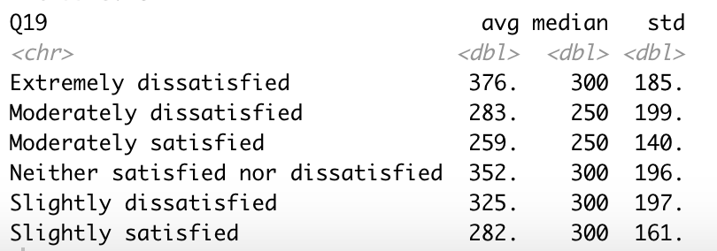

We can observe a pattern here that more satisfaction means less price paid at the bookstore.

However we can look at the distribution of our data. The boxplots are distributions of dollars paid by students across satisfaction levels. The medians are almost the same with similar variances, and thus intuitively there would not be a statistical significance

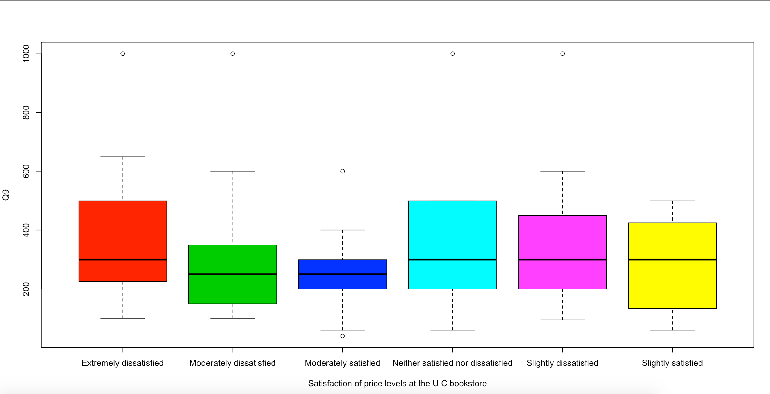

With this information it would be hard to establish a clear picture if the students are satisfied or not. Thus, we will need to collect more information in order to better understand this point.

We can also prove this through a hypothesis test:

An anova test would would confirm this relation

However before this, we need to slice data points of students who bought items from the School bookstore.

Anova Test

Q9 - amount they are spending currently - numeric variable

Q18 - Satisfaction levels of prices at the UIC Bookstore is factor/category hence Anova test

Ho = No relationship between Q9 and Q18

Ha = There is a relationship between Q9 and Q18

Output : p value observed is 0.227

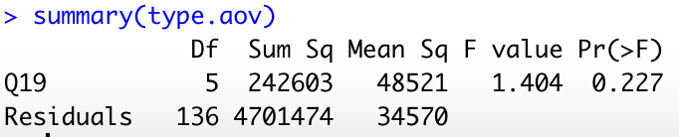

We fail to reject the null hypothesis because the p-value is greater than the alpha level of 0.05. In other words, there's no statistical relationship between amount students are spending currently and their satisfaction levels of prices at the UIC Bookstore.

The Bookstore collection of titles seems to be adequate for students so can infer that the transfer of their current textbooks and course material to the digital format should carter to the demands of students

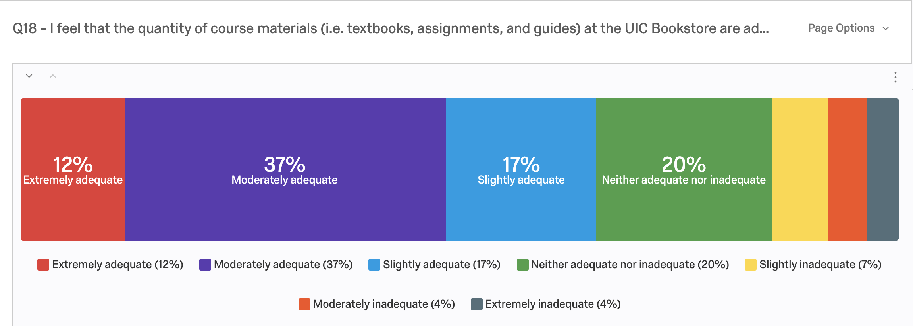

**Objective 6**

Age

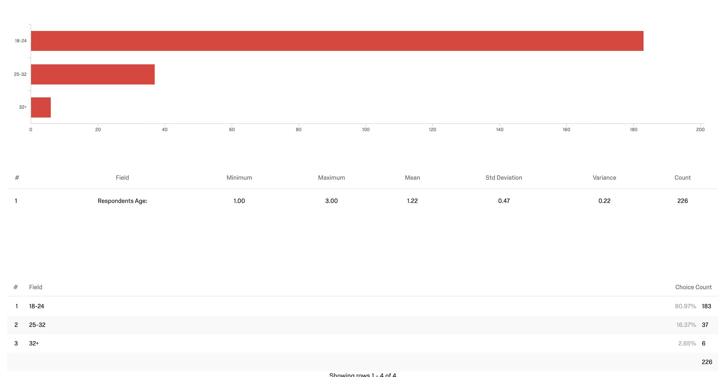

Gender

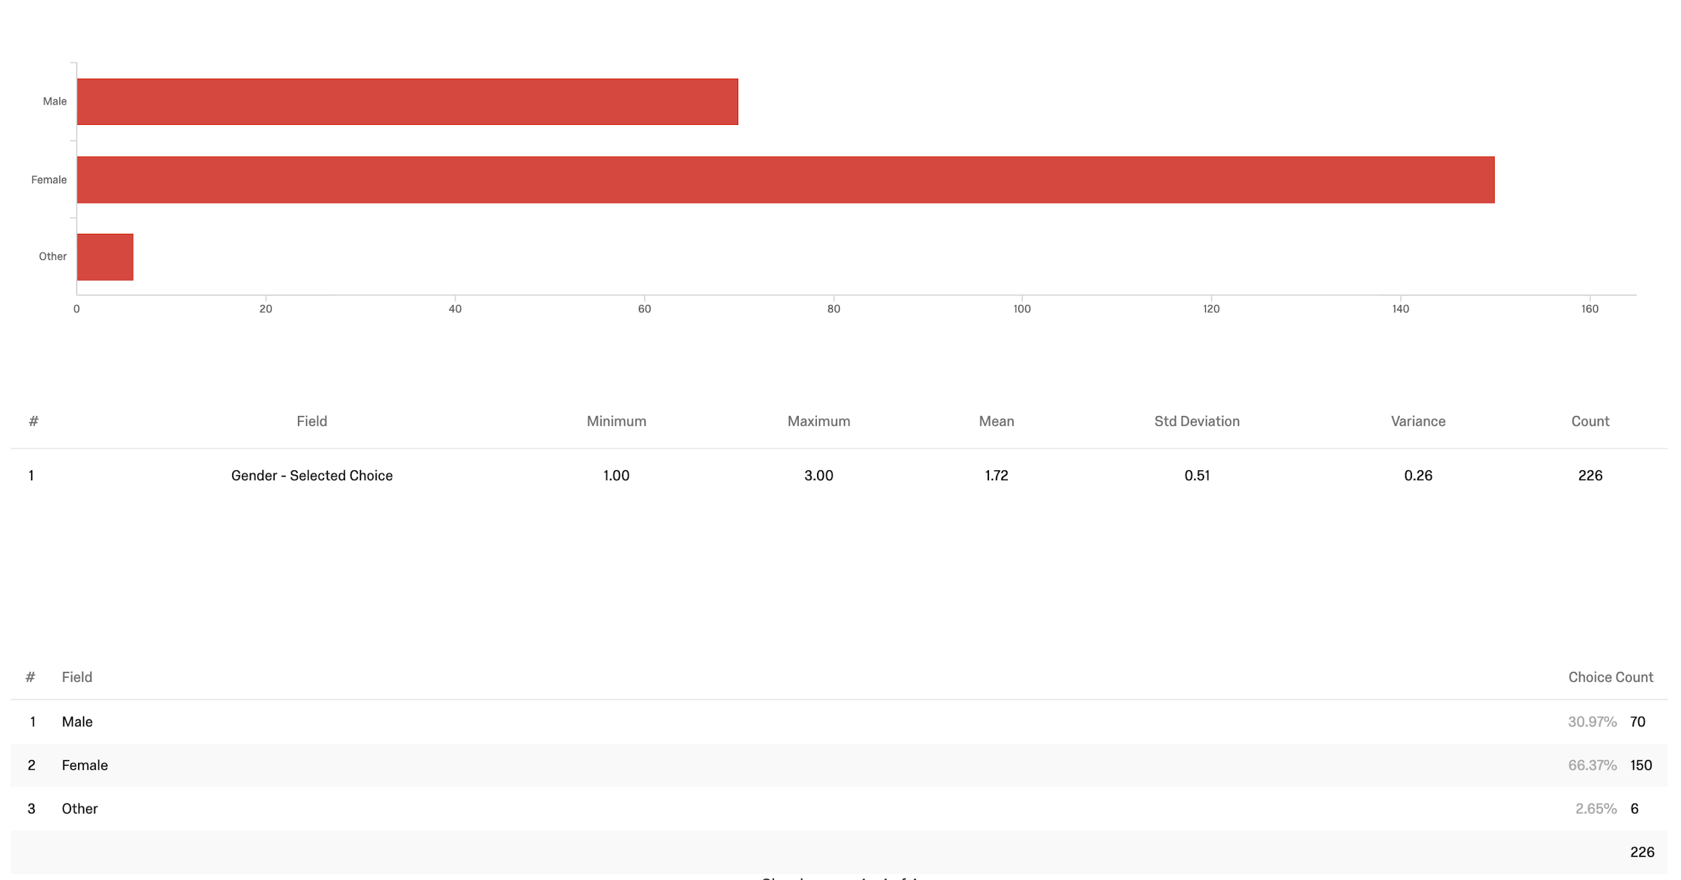

Employment status

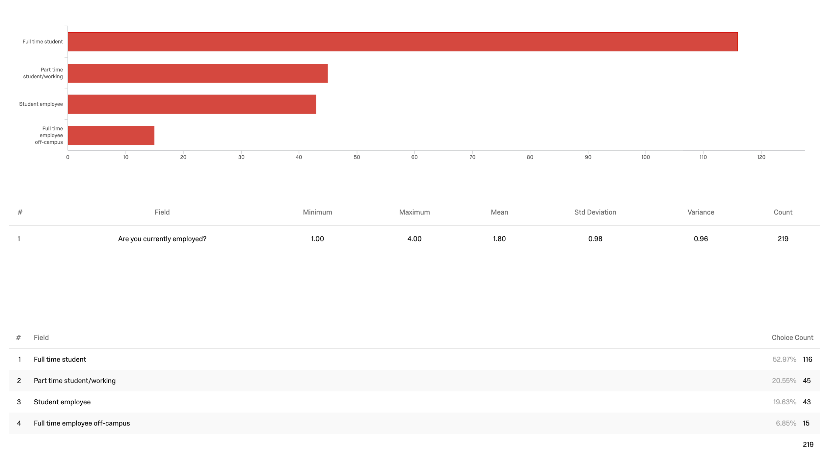

Undergraduate/graduate

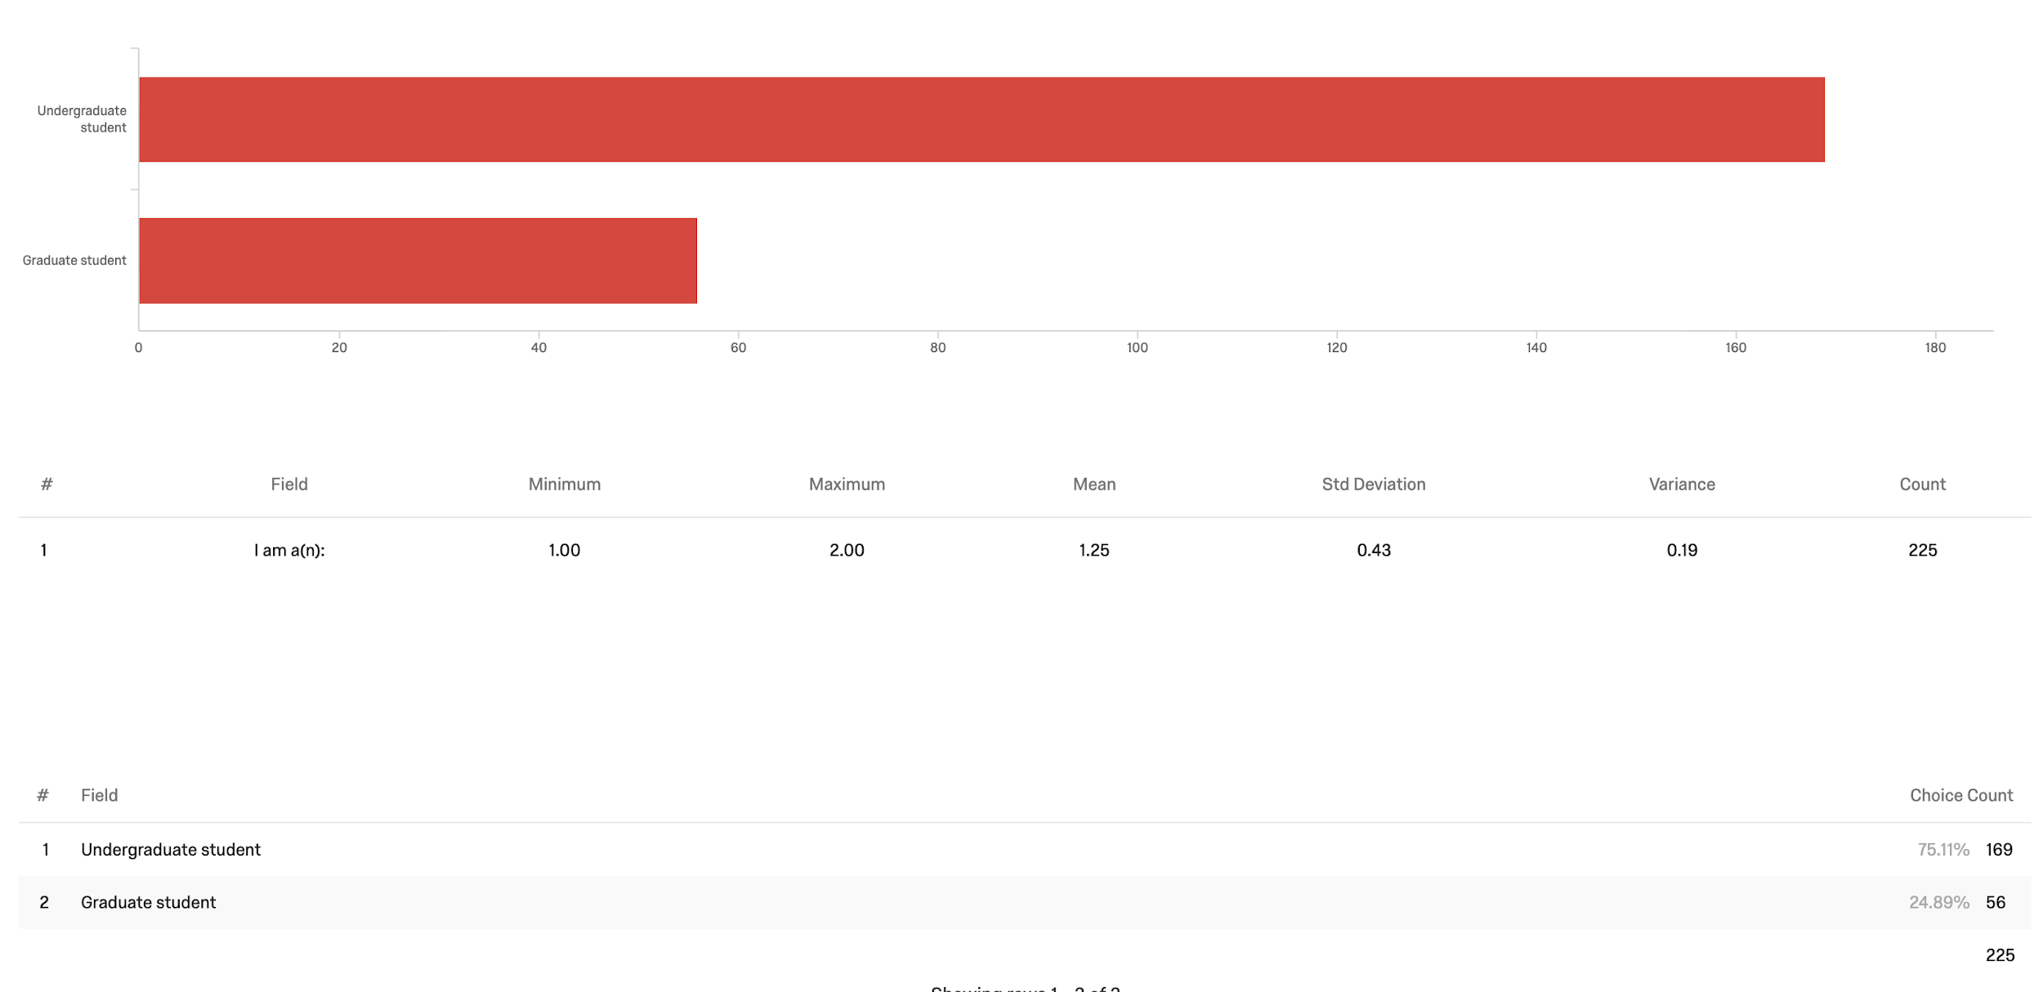

Academic year

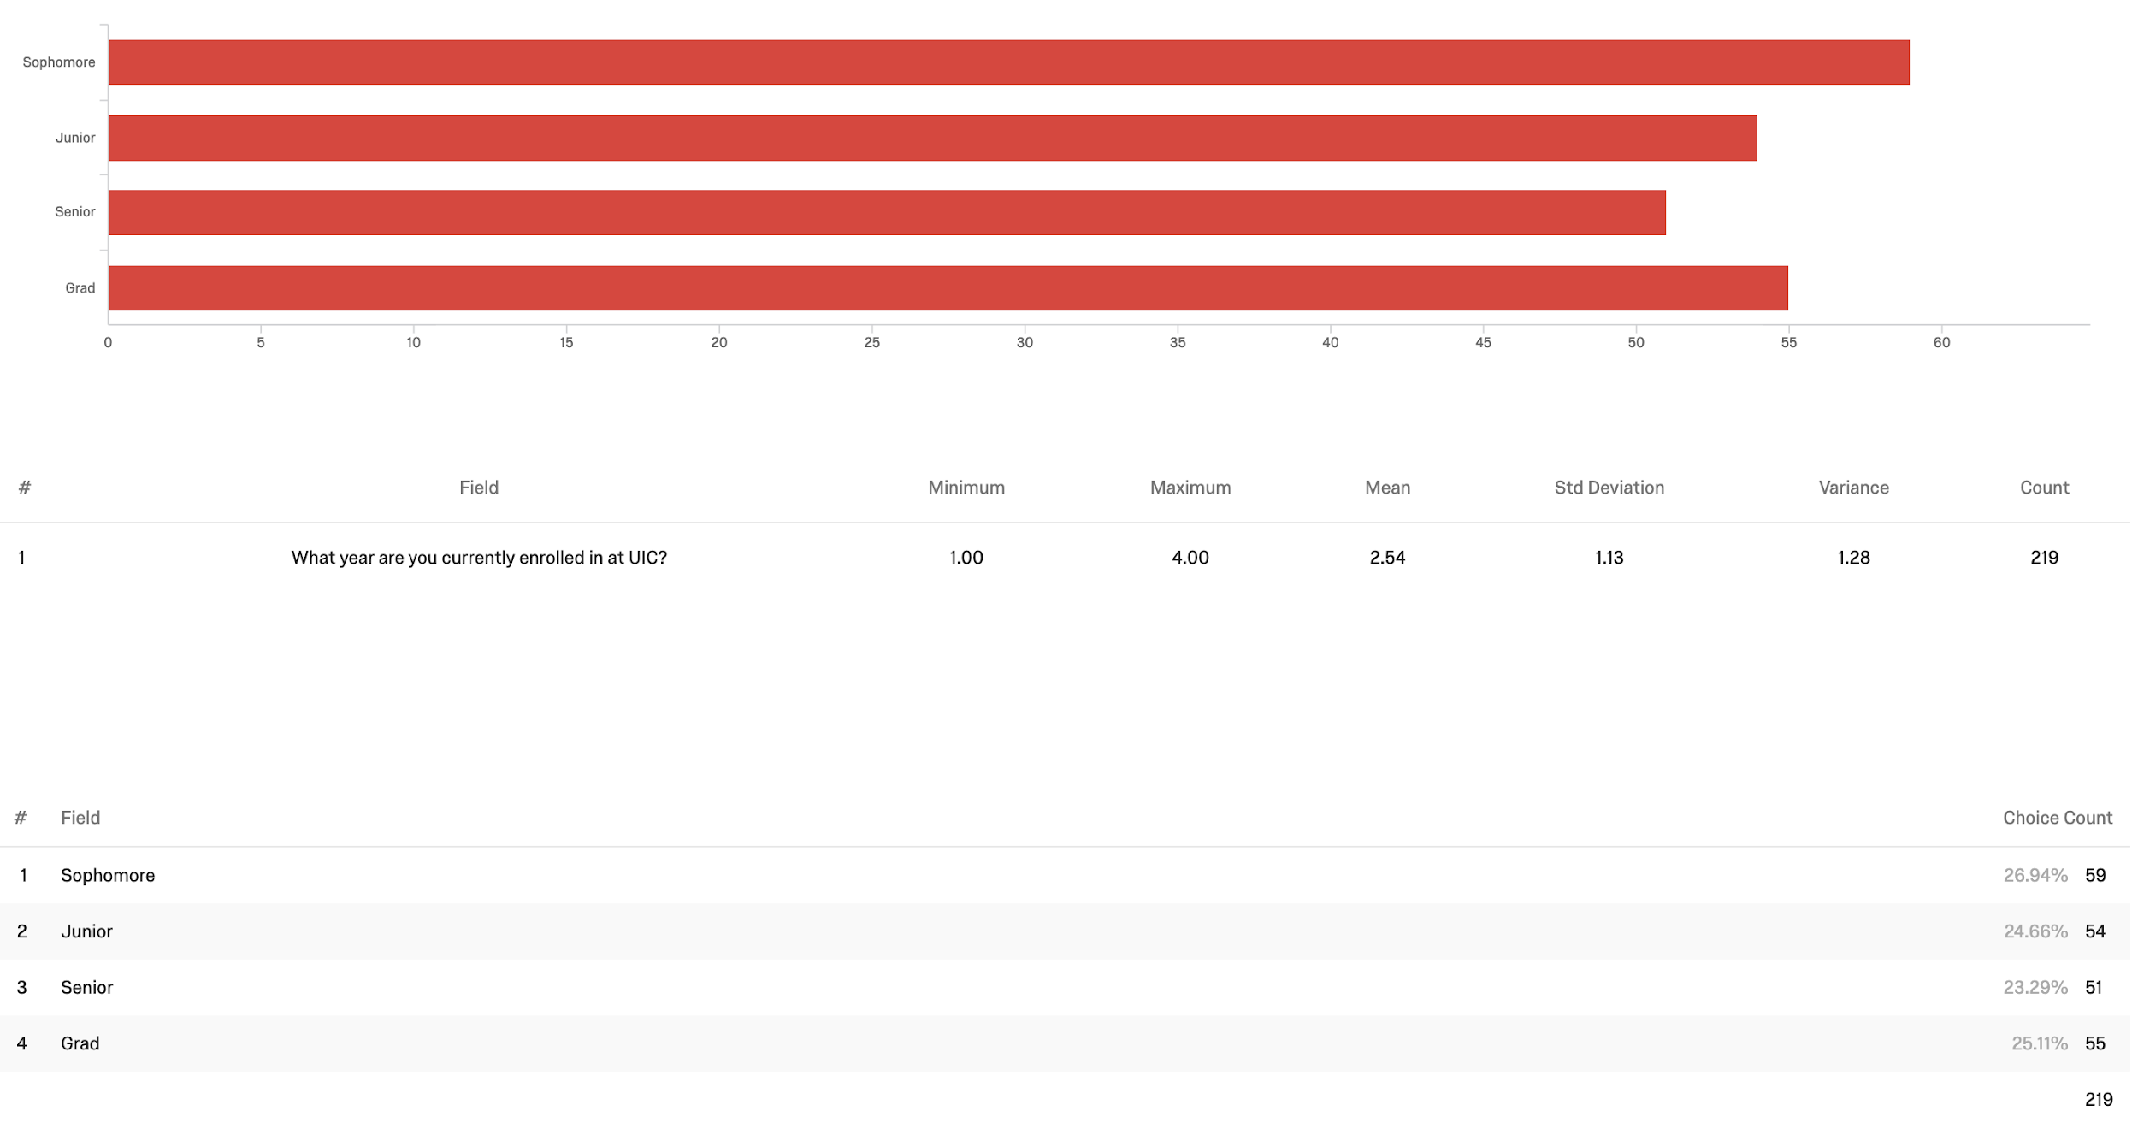

Tuition type

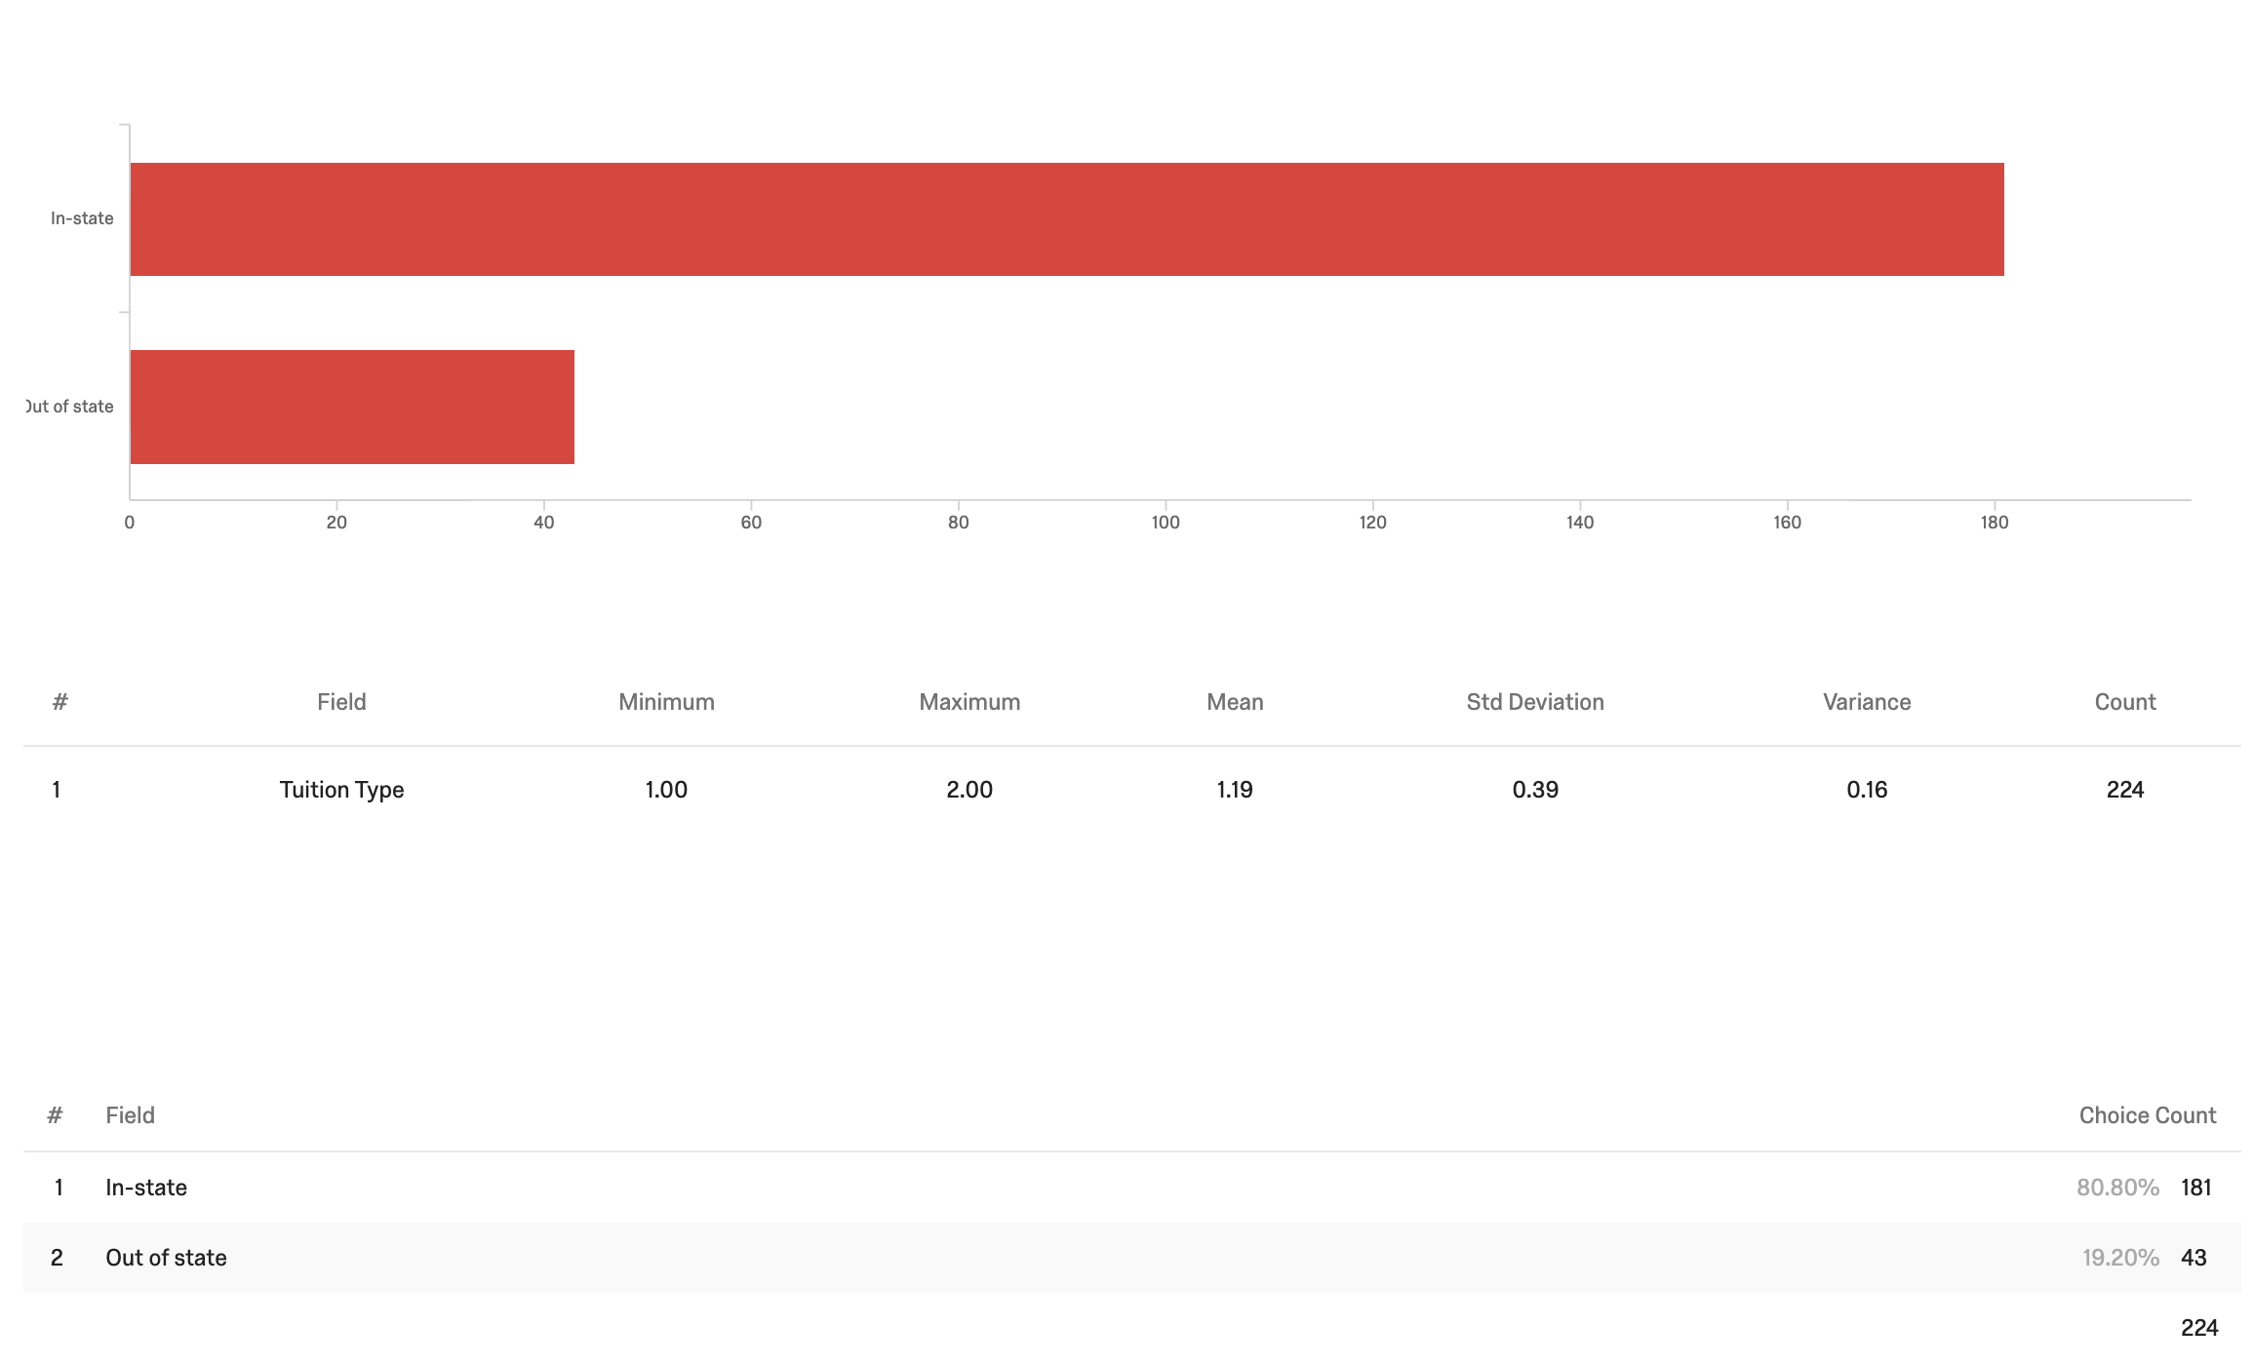

|  |
| --- |
| Summary of Findings |
| **Product Related** |
| * The typical UIC Bookstore customers are: 18-24, female, full-time, undergraduate, in-state students. * Product array is adequate, but there is room in the Bookstore communicating added value. * Amazon is emerging threat to UIC Bookstore hegemony * 76.6% of the students out of the 107 students preferred to buy their course materials online. |
| **Price Related** |
| * Prevailing attitude is: More satisfaction means less price paid at the bookstore. * 86% of the students agreed that it is a financial stress to buy course materials. * Student dollars spent is Positively Correlated to the amount they desire to spend (0.3017).students are spending around $333.13 dollars * Students trust professors in learning how to save while meeting requirements. (‘set it and forget it’ can’t be the teacher default anymore.) |
| **Promotion Related** |
| * There is little-to-no awareness of this DAP, but it makes intuitive sense to students. * Advertising: Students want to be reached in a way that requires a rich media mix that combines legacy formats with new media (digital). * The UIC Bookstore has to invest ad dollars more aggressively moving forward (short term) while accounting for emergent platforms (long term). |
|  |

**LIMITATIONS:**

* The satisfaction levels of students with respect to current prices at the UIC bookstore was inconclusive. All the categories had a similar distribution and median. We would need more information to establish a clear picture if the students are satisfied or not.
* There hasn’t been prior research conducted, which does not provide a research foundation that can be utilized to build this study on.
* Since our primary research data was collected via a survey, there are limitations to the verification of the responses. In other words, we have to accept the responses provided by the students at face value.

**RECOMMENDATIONS**

In this project, we have used in depth research to describe and measure the potential next marketing implications that the UIC Bookstore needs to take into account for the success of their Direct Access Program.

We have aimed to figure out what attributes lead to a subscription, and ultimately leading to value for a student.

Through our research we answered questions such as who are these students, what kind of prices they are willing to pay, what kind of promotional methods are ideal etc.

In order to make the Direct Access program a success at UIC, we propose the following stsp:-

* **Develop a clear Marketing Strategy :** A clear marketing strategy for the entire program is essential. Typically mapping thwe 4p’s of the service and then creating individual approaches to each P.
* **Focus on Price & Promotion:** Out of the 4P’s , the two most important P’s that need a clear strategy are Price and Promotion.
* Target undergraduate/graduate students and professors on campus
* Set competitive prices that are in line with the UIC Bookstore’s fiscal budget as well as the student’s reservation price (~$80-$100 per academic semester)
* **Integrated Marketing Strategy:**-
  + Phase 1 - Professors
    - Send campus representatives to target professors
  + Phase 2 - Educate students
    - Educate students with rich content
    - Publish posters around the campus
    - Hold open houses
    - Send marketing emails

o Phase 3

* Utilize pull strategies
* Leverage social media tools (e.g. Facebook & Instagram)
* Establish seasonal themed discount (e.g. Back-to-School discounts)

In conclusion, UIC Bookstore continues to thrive in its industry despite fierce competition by big box, online retailers such as Amazon and Cengage. UIC’s DAP program has a sustainable competitive advantage being a bookstore program that is connected to one of Chicago’s largest public universities. If the university is able to effectively promote the awareness of the program to its students and professors, the program will be mutually beneficial to both parties.

**Bibliography:**

Danielle, & Douglas-Gabriel. (2018, April 14). Battle over college course material is a textbook example of technological change. Retrieved from:

https://beta.washingtonpost.com/local/education/battle-over-college-course-material-is-a-textbook-example-of-technological-change/2018/04/14/fb3d0394-0db5-11e8-95a5-c396801049ef_story.html?noredirect=on

Kelly 04/18/19, R. (n.d.). Virtual Bookstore to Save Goucher College Students Up to 70 Percent on Textbooks. Retrieved from https://campustechnology.com/articles/2019/04/18/virtual-bookstore-to-save-goucher-college-students-up-to-70-percent-on-textbooks.aspx

Nacs. (n.d.). Higher Education Retail Market Facts & Figures. Retrieved from https://www.nacs.org/research/HigherEdRetailMarketFactsFigures.aspx

Silver, K., & Washington Post. (2017, September 14). Indie Bookstores Embrace the Side Hustle. Retrieved from https://www.citylab.com/life/2017/09/independent-bookstores-creative-business-models-amazon/539724/

Silverberg, J., & Glover, D. (2014, October 22). The Future College Bookstore: Leave The Books, Take The Panini. Retrieved from https://www.fastcompany.com/3036953/the-future-college-book-store-leave-the-books-take-the-panini

<https://uspirg.org/sites/pirg/files/reports/National%20-%20COVERING%20THE%20COST.pdf>

Textbook Trends: How U.S. College Students Source Course Materials. (n.d.). Retrieved from <https://www.nielsen.com/us/en/insights/article/2016/textbook-trends-how-us-college-students-source-course-materials/>.

Nacs. (n.d.). Higher Education Retail Market Facts & Figures. Retrieved from https://www.nacs.org/research/HigherEdRetailMarketFactsFigures.aspx.

Industry Market Research, Reports, and Statistics. (n.d.). Retrieved from <https://www.ibisworld.com/united-states/market-research-reports/book-stores-industry/>.

Consumer Expenditure on Newspapers, Magazines, Books and Stationery Retrieved from:

:<https://www-portal-euromonitor-com.proxy.cc.uic.edu/portal/StatisticsEvolution/index>

Lombardo, C. (2019, May 1). McGraw-Hill to Merge With Rival Textbook Publisher. Retrieved from <https://www.wsj.com/articles/mcgraw-hill-cengage-plan-all-stock-merger-11556683590?tesla=y>.

<https://uspirg.org/sites/pirg/files/reports/National%20-%20COVERING%20THE%20COST.pdf>

Breakdown of students enrolled in grad vs undergrad programs in our university zip code

<https://app-simplyanalytics-com.proxy.cc.uic.edu/index.html>

1. Lombardo, C. (2019, May 1). McGraw-Hill to Merge With Rival Textbook Publisher. Retrieved from https://www.wsj.com/articles/mcgraw-hill-cengage-plan-all-stock-merger-11556683590?tesla=y.
2. Lombardo, C. (2019, May 1). McGraw-Hill to Merge With Rival Textbook Publisher. Retrieved from https://www.wsj.com/articles/mcgraw-hill-cengage-plan-all-stock-merger-11556683590?tesla=y.